Created in the cloud with Aspose.Words for Cloud. http://www.aspose.com/products/words/cloud

# Exposing M Code and Query Metadata of Power BI (PBIX) File

Published Date : June 7, 2017

[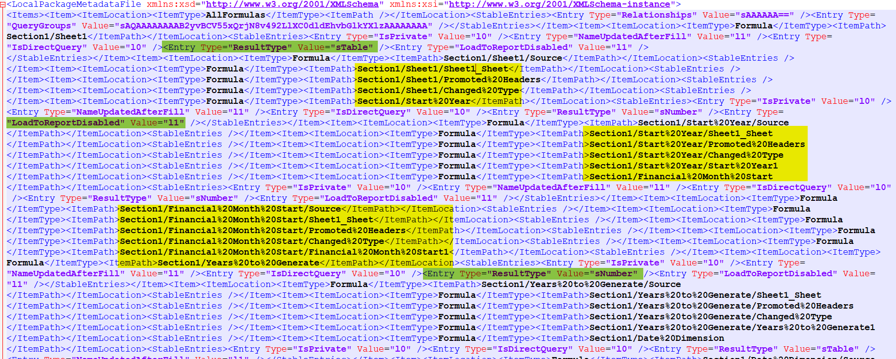](http://radacad.com/wp-content/uploads/2017/06/2017-06-07_11h19_53.png)

Power BI Desktop file stores many metadata information in it, one of the most important piece of information stored there is Power Query M scripts. It is always easy to open a PBIX file and realize the queries in Query Editor Window. However, if you have many queries and you want a way to get the script of all of them then this post is for you. I will explain a bit about the structure of PBIX file at the beginning and then I’ll explain how you can access the M script from it. If you like to learn more about Power BI and Power Query; read [Power BI book from Rookie to Rock Star](http://radacad.com/online-book-power-bi-from-rookie-to-rockstar" \o "Online Book: Power BI From Rookie to Rockstar).

# Structure of a PBIX File

[Gilbert](https://gqbi.wordpress.com/2017/05/02/what-makes-up-a-power-bi-desktop-pbix-file/" \t "_blank) recently written a great blog post about the structure of PBIX file, and I strongly recommend everyone to read it. For this blog post, my focus is on M script section of that. so, I’ll go through other parts of the structure briefly. A Power BI Desktop file is a file with \*.PBIX extension. This file is a renamed version of a ZIP file. You can simply rename the file to \*.zip to see the structure of it. Then you can simply unzip it into a folder.

[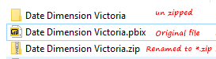](http://radacad.com/wp-content/uploads/2017/06/2017-06-07_09h34_12.png)

Files under this folder are;

[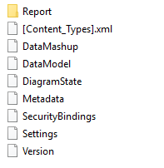](http://radacad.com/wp-content/uploads/2017/06/2017-06-07_09h38_28.png)

Here is a very brief explanation of each file or folder;

* Report Folder: Layout of the Power BI visual reports (Including two files in the folder)
* [Content\_Types].xml: Includes the content structure of this folder in XML format (older PBIX files might have different content structure)
* DataMashup: This is the file which is main topic of this blog post. It includes everything related to Power Query side of the file; M scripts, structure of queries, parameters, and functions.
* DataModel: This actually includes the data in the model (in a compressed format).
* DiagramState: It seems it stores the table and Matrix information.
* Metadata: Contains all labels (Names). In Power BI Desktop, everything has a GUID assigned to it. what we see as a table name, has a GUID assigned to it. This file is mapping of GUIDs and names that we see.
* SecurityBindings: I believe this is Row Level Security configuration in the Power BI stored in binary format.
* Settings: I believe it is some of the settings applied in Power BI settings menu options.
* Version: Version of the file.

in the future I’ll write some other posts with detailed explanation of every file and folder. For now, let’s focus on DataMashaup File.

# DataMashup File: Everything You Need

Talking about Power Query; DataMashup file is all you need. It includes everything from the structure of queries, tables, parameters, list, to the actual M scripts behind the scene. You can Fetch all of these information from this single file. Let’s look at the structure of this file. If you open this file with a text editor. you will see some binary things first (which are related to the zipped nature of this file), and also some XML information. Yes, this is a zipped file. Let’s start with unzipping it into a folder. I’ve done that with 7-zip application.

[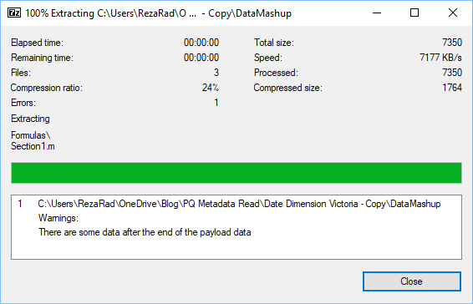](http://radacad.com/wp-content/uploads/2017/06/2017-06-07_09h58_44.png)

In the folder you will have these files:

[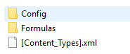](http://radacad.com/wp-content/uploads/2017/06/2017-06-07_09h59_35.png)

Here are details of each file;

* [Content\_Types].xml: explains the content of this section, very high level information. it is just saying that M script are somewhere in this folder

[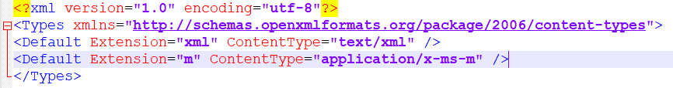](http://radacad.com/wp-content/uploads/2017/06/2017-06-07_10h02_13.png)

* Config Folder:  Includes one file: Package.xml, which is the information about settings of Power Query. For example the culture, versioning, and some other configurations.

[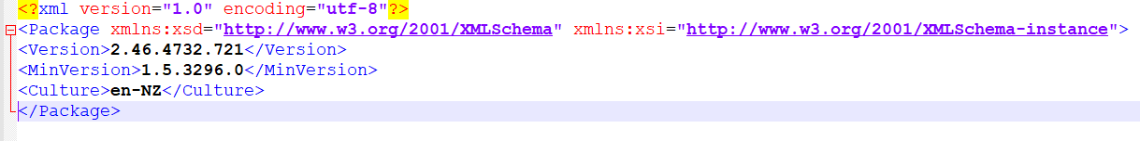](http://radacad.com/wp-content/uploads/2017/06/2017-06-07_10h03_58.png)

* Formulas Folder: Includes M scripts! files with \*.m extension.

[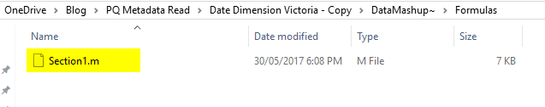](http://radacad.com/wp-content/uploads/2017/06/2017-06-07_10h05_28.png)

You might end up having more than one file if you have more than 1 section, but this is unlikely to happen in usual cases. Usually everything you do in Query Editor goes under single section. If you are a M geek and know how to write multiple sections, then you might end up with having multiple files ;) I will write another post in the future explaining Sections and their usages. For now, let’s look at this \*.m file with a text editor:

# M Script File

Section1.m File gives you all M script in well formatted text;

[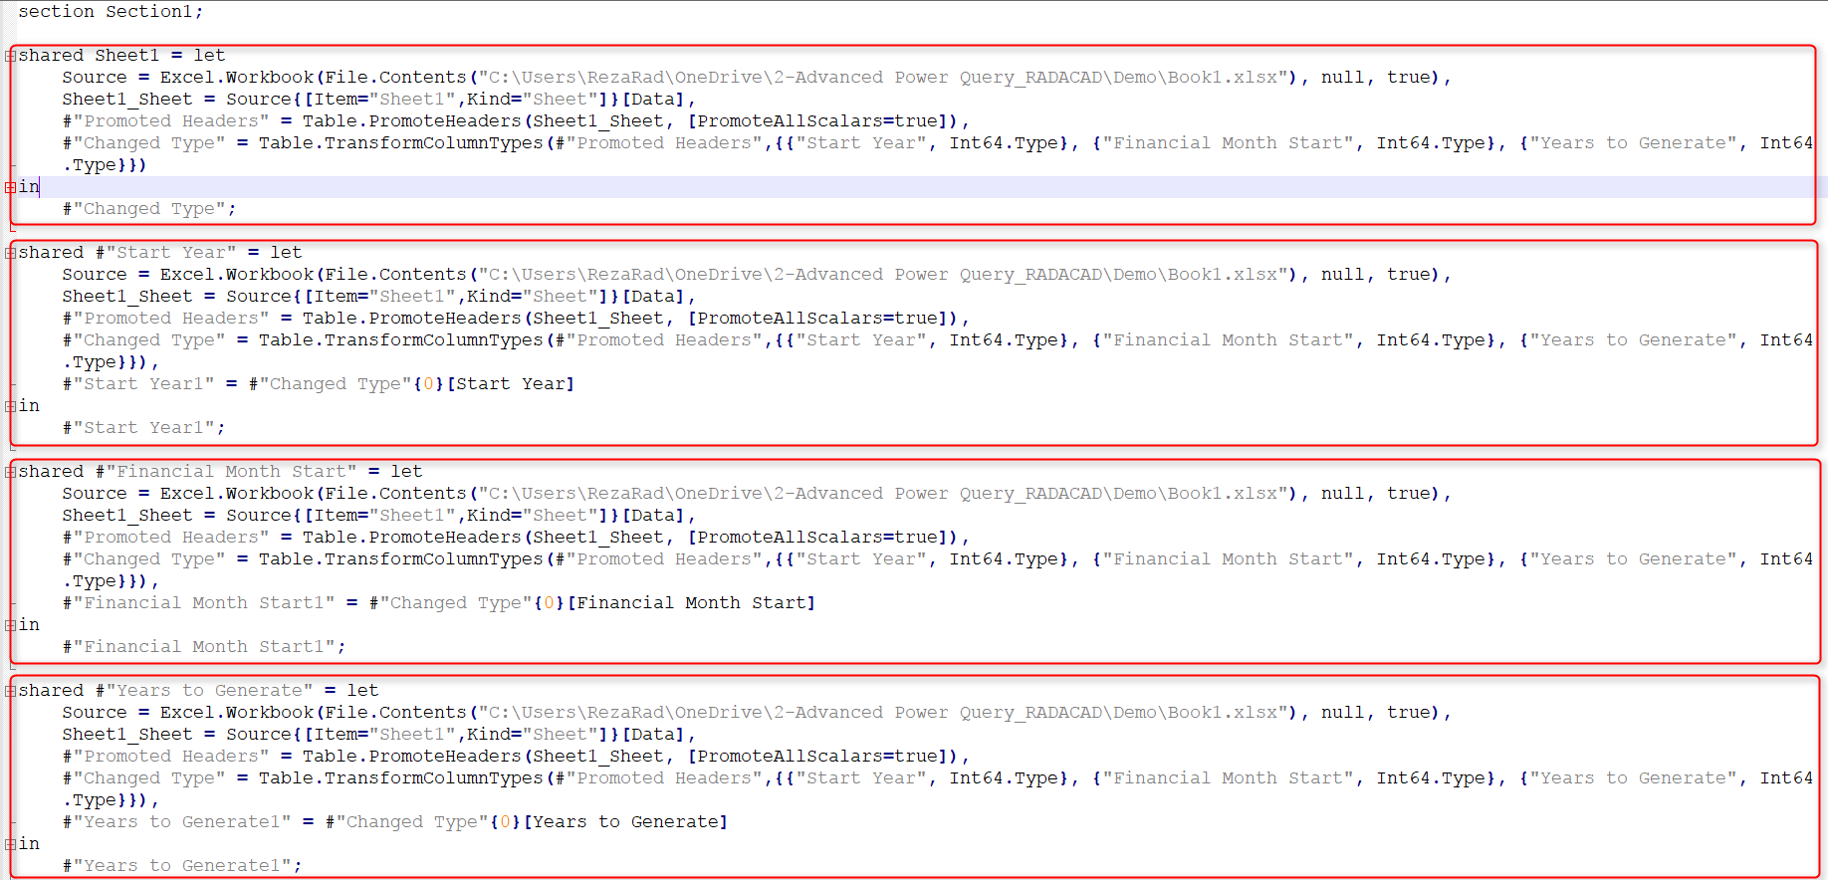](http://radacad.com/wp-content/uploads/2017/06/2017-06-07_10h08_10.png)

If you need to send your M scripts to someone this is the place to copy them from. This includes every single M script all in one place (as long as they are all under one section). Here is the actual Power Query’s Query Editor list:

[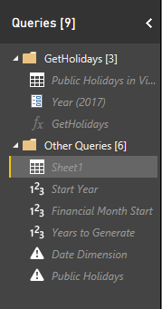](http://radacad.com/wp-content/uploads/2017/06/2017-06-07_10h14_42.png)

all of these queries, parameters, and functions are in the section1.m file. You can easily understand if they are query, parameter of function. Look at screenshot below;

[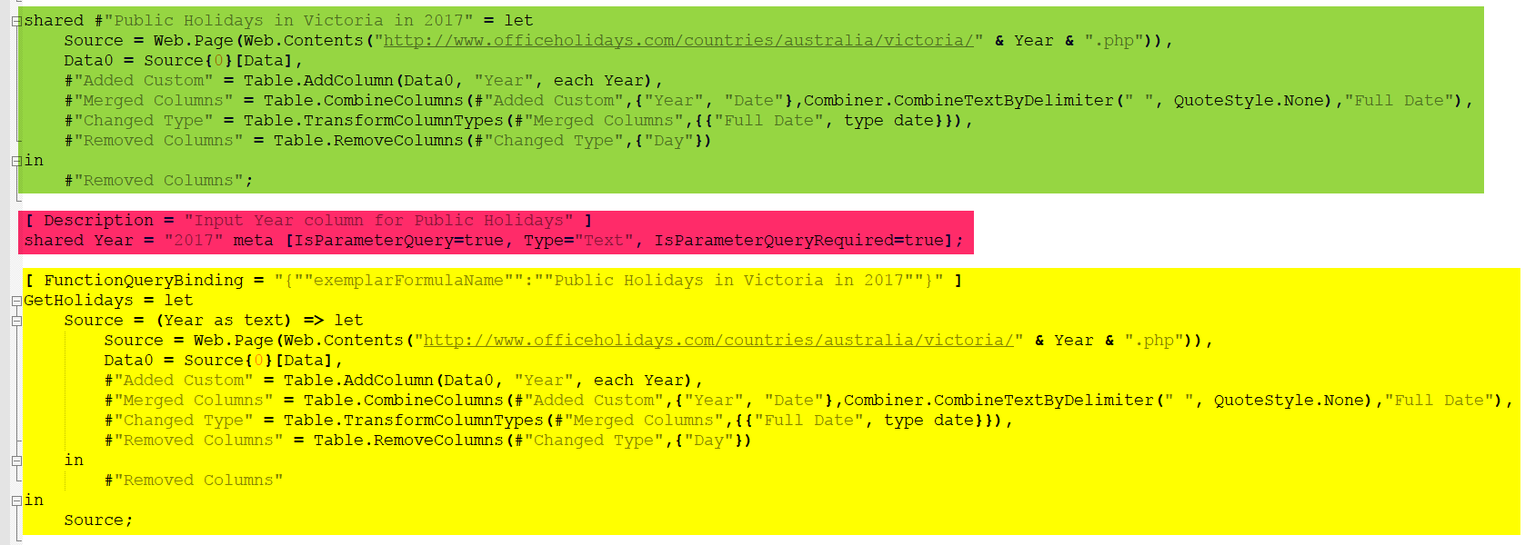](http://radacad.com/wp-content/uploads/2017/06/2017-06-07_10h13_17.png)

Queries are just starting with let expressions. However, for parameters there is a meta information:

meta [IsParameterQuery=true, Type="Text", IsParameterQueryRequired=true]

for functions; there is a FunctionQueryBinding section which explain where the function is sourced from;

[ FunctionQueryBinding = "{""exemplarFormulaName"":""Public Holidays in Victoria in 2017""}" ]

Green section above is a simple query

Red section is a parameter

and Yellow section is a function

So, very easily you can access all queries pane from this area. However, this doesn’t tell you the folder structure, or some other query editor settings. For example, many of these queries are not loading in Power BI and disabled for load. This \*.m file doesn’t tell you that. That information, however, exists somewhere else. let’s look at that.

# Metadata Information in XML Format

If you open the DataMashup file in a text editor (like Notepad++) you will see another story. content starts with some binary characters, but then some XML codes appears.

[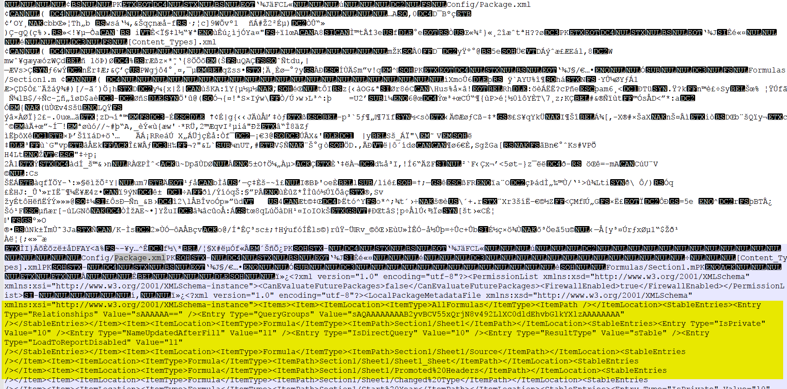](http://radacad.com/wp-content/uploads/2017/06/2017-06-07_11h14_05.png)

Starting binary data are related to the zipped nature of this file (which we’ve already went through it in previous part of this post). After binary characters, some XML code starts, which includes some schema definition. You will easily find all the metadata information between these tags;

[](http://radacad.com/wp-content/uploads/2017/06/2017-06-07_11h17_59.png)

all useful information are under LocalPackageMetadataFile tags. you can simply remove everything else. After removing everything else and keeping only the content between these tags, then you will have XML structure that includes all metadata information about Power Query’s Query Editor;

[](http://radacad.com/wp-content/uploads/2017/06/2017-06-07_11h19_53.png)

As you can see in above screenshot, there are XML tags for all attributes; name of every step and query (highlighted yellow), and their properties (highlighted green) such as LoadToReportDisabled, ResultType and Value.

If you be a Power Query geek like myself, you would dig into this structure with Power Query Itself! I have opened another Power BI Desktop file, and got data from this file; DataMashup File. I have done some steps, such as removing everything before and after main xml tags, then drilled into different sections of it, and I’ve got some results such as this:

[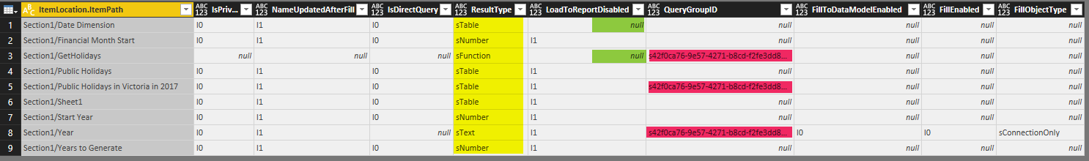](http://radacad.com/wp-content/uploads/2017/06/2017-06-07_11h28_21.png)

As you can see it is fairly obvious that is the query Parameter, Function or a normal Query(highlighted yellow). Is the query inside a group or not (highlighted red), or is it enabled load in the report (highlighted green), and many other information.

[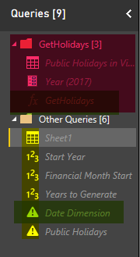](http://radacad.com/wp-content/uploads/2017/06/2017-06-07_11h31_45.png)

Here you go. You have all you need in terms of understanding the metadata of tables, queries, parameters, and functions.

# Summary

DataMashup file in \*.pbix file included all you need to access to Query Editor’s metadata information, and also the M scripts. You can simply use this file to access to the whole code behind of Power Query component of your Power BI solution. In future posts I’ll go through steps of exploring data from the XML content in DataMashup file and also explain other files under \*.pbix file. There are still a lot of information in XML content of DataMashup file, I encourage you all to explore it with Power Query and open your eyes to the world of metadata of Power Query :)

Tell me what part of this DataMashup file and metadata information you like most in the comments.

# Power BI Premium. Is It For You or Not?

Published Date : May 15, 2017

[](http://radacad.com/wp-content/uploads/2017/05/sohum-raninga-116860.jpg)

There were many announcements earlier this month about Power BI. One of them which was and still is the breaking news of all is Power BI Premium. Many of you already know that it is a new licensing plan, but how it works? Is this a licensing plan that works for you or not? What is the break-even point with this plan? In this post I’ll answer all of these questions with a detailed explanation about Power BI Premium. If you want to learn more about Power BI; read [Power BI book; from Rookie to Rock Star](http://radacad.com/online-book-power-bi-from-rookie-to-rockstar" \o "Online Book: Power BI From Rookie to Rockstar).

# Power BI Licensing Before Premium

To look at the new licensing plan, it is best to first understand how the previous licensing worked. Before this change, licensing plan for Microsoft were simple, it had only two plans: Free, and Power BI Pro. Free was free of charge obviously. All you needed was just your company email address to get Power BI account. Pro, however provided some additional features with a cost of about $9.99 per user per month.

Difference between these two plans was not about development work. You can do almost anything you want with Power BI free for doing the development work. But, when it comes to contribution, sharing, security, and using Power BI in production environment, most of features needed Pro account. Here are the details in a table;

| **Feature** | **Power BI Free** | **Power BI Pro** |
| --- | --- | --- |
| Space allocation | 1GB | 10GB \* |
| Power BI Desktop | Yes | Yes |
| Development features | Yes | Yes |
| DirectQuery or LiveQuery | No | Yes |
| Data Set Refresh Frequency | up to once a day | up to 8 times a day |
| Gateways – On-premises data source | No | Yes |
| Row Level Security | No | Yes |
| Content Pack | No | Yes |
| Work Spaces | No | Yes |
| Data Streaming | up to 10K rows per hours | unlimited |

[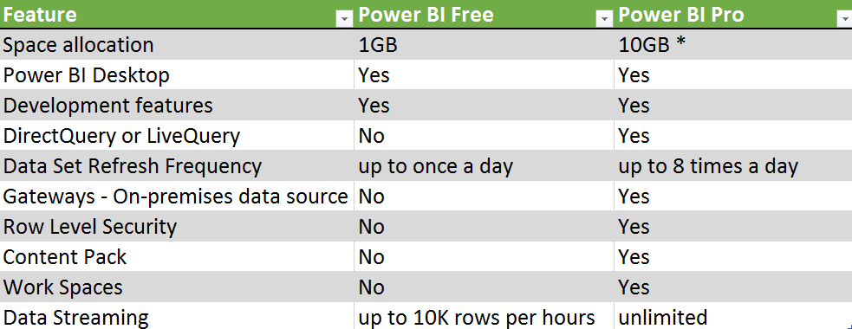](http://radacad.com/wp-content/uploads/2017/05/2017-05-15_05h08_51.png)

As you can see anything regarding to Developing a Power BI solution is available for free. However, for using Power BI in a production environment, most of the time you require Pro account. Here is more details;

* If you want to use a proper mechanism to share Power BI content with others, in most of the cases you need to use either Power BI [work spaces](http://radacad.com/groups-in-power-bi" \o "Groups in Power BI), or [Content Packs](http://radacad.com/content-pack-sharing-self-service-and-governance-together" \o "Content Pack; Sharing, Self-Service and Governance Together), which both are Pro features.
* If you want to use [Row Level Security](http://radacad.com/row-level-security-configuration-in-power-bi-desktop" \o "Row Level Security Configuration in Power BI Desktop), which is giving access to users based on their part of the data set, not the whole, then you need Pro account.
* If you are using [Gateways](http://radacad.com/step-by-step-walk-through-on-premises-live-sql-server-connection-with-power-bi-enterprise-gateway" \o "Step by Step Walk through: On-Premises Live SQL Server Connection with Power BI Enterprise Gateway) (doesn’t matter [Personal](http://radacad.com/definitive-guide-to-power-bi-personal-gateway" \o "Definitive Guide to Power BI Personal Gateway) or On-Premises) to connect to on-premises data source, then you need Pro account.
* For LiveQuery or DirectQuery connection to data sources you will need Pro account. LiveQuery or DirectQuery option happens a lot in enterprise environment when the size of data and scale is so high, that Power BI 1GB model cannot host it.
* and many more as you see in the table above

As you can see, in production environment of using Power BI, you will hit one of the limitations above for Free account, and you have to use Pro Account. This is very important to understand that;

Pro account is not only for developer, but also for consumer! If Power BI Content is Pro, then whoever uses and consumes that content should have Pro account.

Yes, you’ve read it correctly. Any content, that has one of below features considered as Pro content. and everyone who uses or consumes that content, should have Power BI pro account;

* Data from a DirectQuery dataset, such as [SQL Server Analysis Services](https://powerbi.microsoft.com/en-us/documentation/powerbi-sql-server-analysis-services-tabular-data/) tabular data, [Azure SQL Database](https://powerbi.microsoft.com/en-us/documentation/powerbi-azure-sql-database-with-direct-connect/), [Azure SQL Data Warehouse](https://powerbi.microsoft.com/en-us/documentation/powerbi-azure-sql-data-warehouse-with-direct-connect/), or Apache [Spark for HDInsight](https://powerbi.microsoft.com/en-us/documentation/powerbi-spark-on-hdinsight-with-direct-connect/).
* Data from a [dataset that refreshes more frequently than daily](https://powerbi.microsoft.com/en-us/documentation/powerbi-refresh-data/).
* Data from a dataset that connects to on-premises data using the [Power BI Gateway – Personal](https://powerbi.microsoft.com/en-us/documentation/powerbi-personal-gateway/) or the [On-premises Data Gateway](https://powerbi.microsoft.com/en-us/documentation/powerbi-gateway-onprem/), and for which a scheduled refresh is set.
* Data from a live connection to Azure Analysis Services.
* Data (including reports, dashboards or tiles) from a dataset that uses [Row-level security (RLS)](https://powerbi.microsoft.com/en-us/documentation/powerbi-admin-rls/).
* A dashboard or report that’s installed from [an app](https://powerbi.microsoft.com/en-us/documentation/powerbi-service-what-are-apps/) or an [organizational content pack](https://powerbi.microsoft.com/en-us/documentation/powerbi-service-organizational-content-packs-introduction/).
* A dashboard, report, or dataset that’s contained in an [app workspace](https://powerbi.microsoft.com/en-us/documentation/powerbi-service-create-apps/).
* A dashboard that contains data streamed at a rate above 10k rows/hour.

Source from: [https://powerbi.microsoft.com/en-us/documentation/powerbi-power-bi-pro-content-what-is-it/](https://powerbi.microsoft.com/en-us/documentation/powerbi-power-bi-pro-content-what-is-it/" \t "_blank)

# Why Premium?

With list of limitations for Power BI free and also pro account, it is almost obvious why we need another licensing plan (Premium). I just point few of them here for more elaboration;

### Large User Base

Limitations in Pro Content as above means that if you are working in a large organization with 10,000 users, and you have to pay 10,000 \* $10 per month, which would be $100K per month! or $1.2 million per year! This sounds scary!

### Power BI Model Size Limitation

Also as you might already know; with Pro account you get 10GB space in your Power BI account. However, each Power BI Model (or let’s say file), cannot be more than 1GB! This means you have to combine then Power BI with other technologies such as SQL Server Analysis Services for LiveQuery connection, or a premier database provider such as SQL Server, Oracle, Teradata… for DirectQuery Connection. And that means paying for licenses for those products too. Because in enterprise environment it is very likely that size of Power BI model rise to more than 1GB.

### Readers or Consumers

In most of the implementations of Power BI, majority of users are just readers or consumers of the report. Readers or consumers CAN interact with the report, they can use charts and visuals interactively and analyze the data, but they won’t create or update reports. There is always small amount of developers who do the development work. In this licensing plan, every user who is using Pro content, regardless of the role (developer, or consumer), should be pro account. This sounds like paying more than what you should pay!

[](http://radacad.com/wp-content/uploads/2017/05/olu-eletu-13086.jpg)

# What is Power BI Premium?

Now that you know about previous licensing plan of Power BI, I can start writing about Premium. What is the premium? Power BI Premium, is simply a licensing plan that covers limitations of Power BI pro account. It is a licensing plan that helps overcome what you couldn’t easily achieve with Power BI pro account. The license start at higher ground, at the time of writing this post it is $5K, but don’t be scared from this high cost, we will get into details of that shortly.

[](http://radacad.com/wp-content/uploads/2017/05/maarten-van-den-heuvel-92575.jpg)

### Is Power BI Pro and Free Gone Now?

No! Power BI Free and Pro are still there. However, there will be some changes in features supported by each type of account. I assure you here that all you can do with Power BI pro, you can still do it with Pro, so you don’t need to upgrade to Premium if you don’t want to.

Features that might be taken away from free are more about collaboration, such as sharing. So, in the feature for sharing Power BI content, you might need at least Pro account.

### I Am Currently Using Power BI Pro, Is Premium The Only Option Now?

No! You can continue using Power BI Pro. Pro gives you all you have already, you won’t lose anything. and you don’t have to upgrade to Premium. However, using Premium gives you some more options and features, let’s look at them as below.

## What Are Benefits of Power BI Premium?

Power BI Premium is an additional licensing plan. Additional means that you can use it or not, if you use this plan, then you would get some benefits that helps you to reduce costs of your BI solution sometimes. But, first you need to know what these features are. These features might be superb features for some companies, but not essentials for others.

### Dedicated Power BI Resources

First and one of the most important features of Premium is that you get dedicated resources, such as capacity, cores and processing units. Normal Power BI Free or Pro accounts are publishing contents into SHARED Power BI servers. These servers are definitely high performing servers with great cores and capacity, however it is not dedicated.

With Power BI Premium, you can choose type of node that you want, and configure your own Power BI node, here are nodes as for now;

[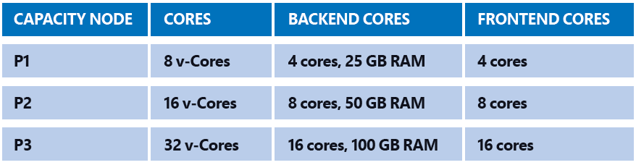](http://radacad.com/wp-content/uploads/2017/05/2017-05-15_05h56_21.png)

### Larger Data Sets Supported

As you already know from Pro limitation; even with Pro account you cannot have a model with more than 1GB of size, and your total space is about 10GB. With Power BI Premium you can have up to 100TB space to fill in! Your model can simply be sized 50GB, or more in near future. This means you might not need paying for additional SQL Server or another database technology for developing large scale BI solution.

### More Frequent Data Set Refresh Rate

With Free you can refresh up to once a day. With Pro you can refresh up to 8 times a day. With Premium you can refresh your data set up to 48 times a day. The minimum frequency for refreshing data was 30 minutes, which is lifted in Premium. You can schedule on a minute level now with this new plan.

### Readers or Consumers Plan

Power BI Premium is a licensing plan for readers and consumers. Readers can enjoy consuming a content that is still a Pro content, but with a licensing that costs less than Pro per user. So, if your company has 10K users, you don’t need to pay $100K per month, you would pay far less than that. I will get into the details of costs shortly.

# Power BI Report Server

This part would need its own blog post of course, and is without a doubt one of the best offerings of Power BI Premium. Previously I have written about [Power BI reports on Premises with Reporting Services](http://radacad.com/power-bi-on-premises-hello-world" \o "Power BI On-Premises; Hello World!). This functionality will be available as a new feature called Power BI Report Server. Power BI Report Server will be part of Premium licensing. So with purchasing Premium licensing  you would be able to host your reports on-premises. More details about costs will come. But the good news is that you will have Power BI on-premises. To understand how that might work, read [my blog post about hosting Power BI report on-premises](http://radacad.com/power-bi-on-premises-hello-world" \o "Power BI On-Premises; Hello World!).

[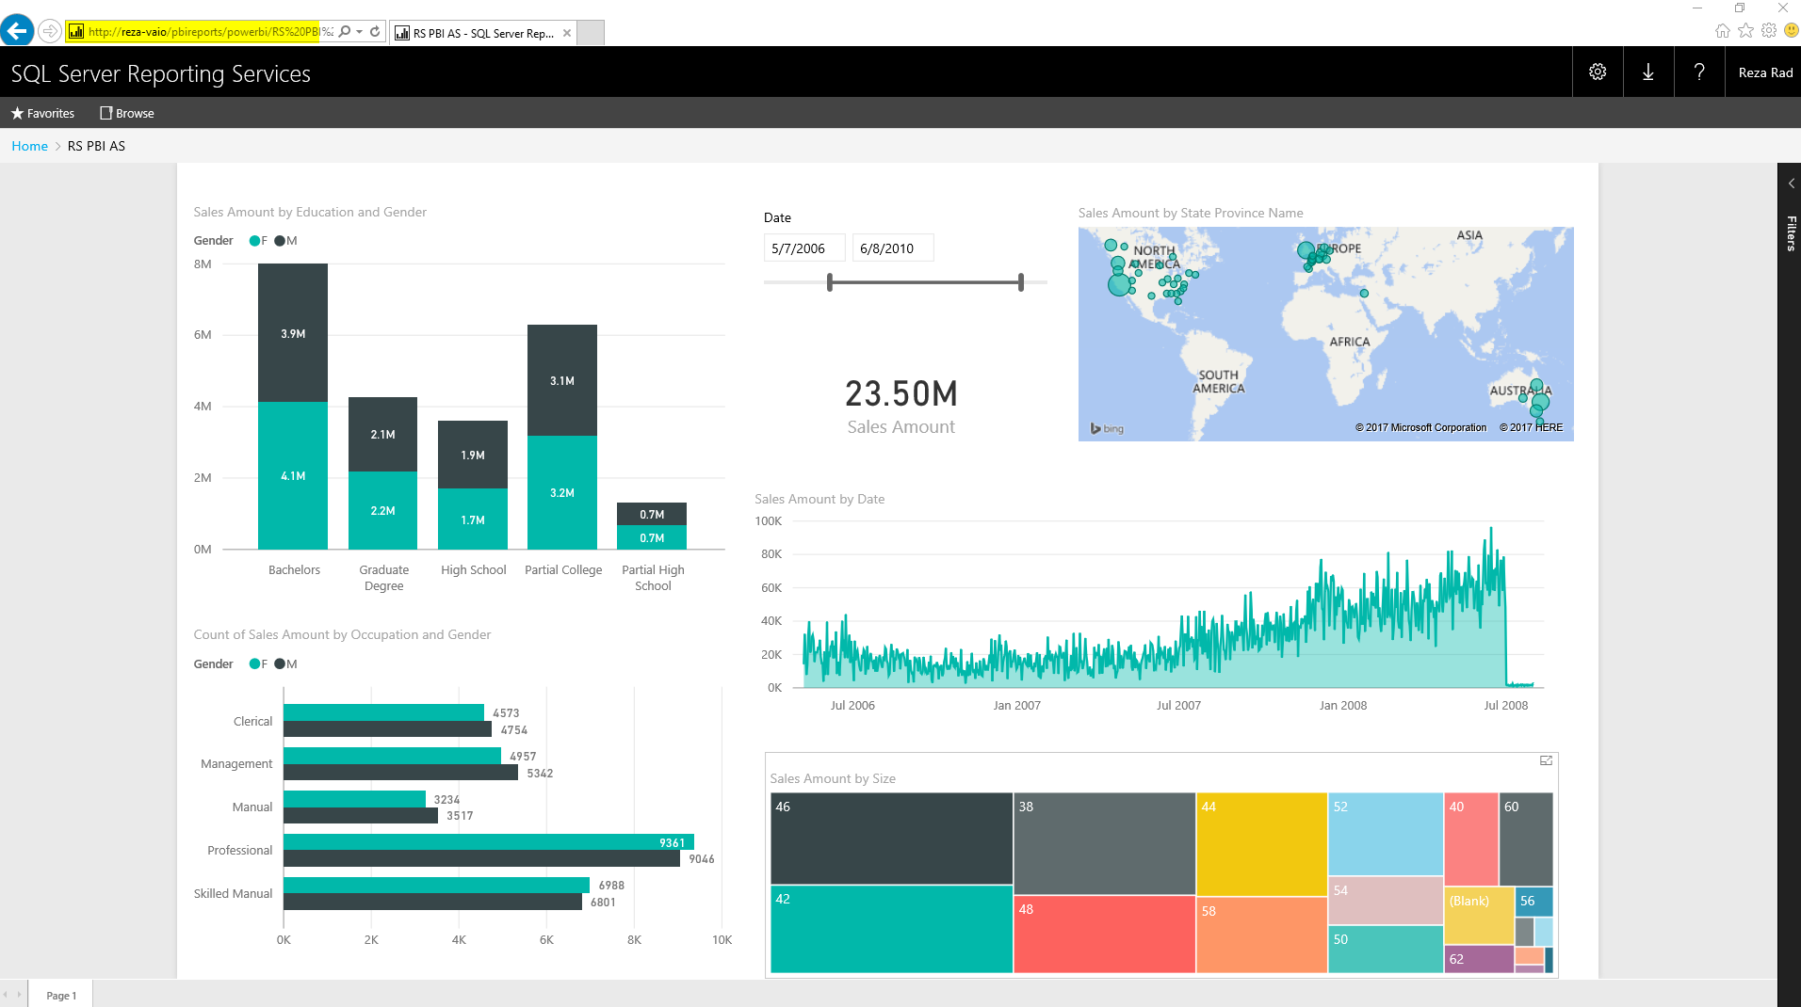](http://radacad.com/wp-content/uploads/2017/01/2017-01-18_20h32_31.png)

## Upcoming Features for Premium

Power BI Premium would be the best offering of Power BI, and there are lots of awesome features coming in for it in near future, such as below. Note that at the time of writing this post, features below are not available yet. These are in the road map.

[](http://radacad.com/wp-content/uploads/2017/05/evelyn-paris-33500.jpg)

### Incremental Refresh

When we are talking about data set more than 1GB of the size, then incremental refresh matters. You don’t want to populate that amount of data in every refresh. With Premium you will have this option in near future to use incremental load and update only changed set.

### Pin Data Set to Memory

Power BI by default allocate memory to models based on their usages. This automatic allocation sometimes might cause users to wait for their old report to load. In the feature you will have option to pin those data sets that you think are important and critical for business to memory and configure performance of Power BI based on your requirements.

### Dedicated Data Refresh Node

You would be able to dedicate specific nodes for data refresh, while other nodes are providing response to report. This will help performance of report loading to be high while data set is refreshing.

### Geo-Replica and Read-Only Replicas

You will be able to distribute replicas of Power BI model geographically and in other ways, so your users get the best performance.

# The Most Important Topic! Costs of Premium

Cost of Power BI Premium is the most important topic to discuss. When Premium announce first time, I have seen lots of people scared from the $5K entry point of it. Let’s get into details of costing and see how it is working.

[](http://radacad.com/wp-content/uploads/2017/05/vitaly-145502.jpg)

There is a [calculator](https://powerbi.microsoft.com/en-us/calculator/" \t "_blank) that helps you understand the costing based on your requirement. Basically the costing is based on how many developers (Pro) accounts you have, how many frequent users, and how many readers. The reason to separate frequent users and readers are mainly to understand how many cores you will need for Power BI Premium.

Let’s go through an example. Consider an organization with 10K users. out of these 10K uses, only 300 of them are developers (they will create or update reports), rest are just consuming reports (Let’s say 4.8K frequent consumers, and 4.8K occasional). Based on the calculator for such requirement, you will need to have 300 Pro users (this is obvious), and 6 P1 nodes to cover readers. Each P1 Node costs $5K per month.

So as a result it would costs about $32K;

[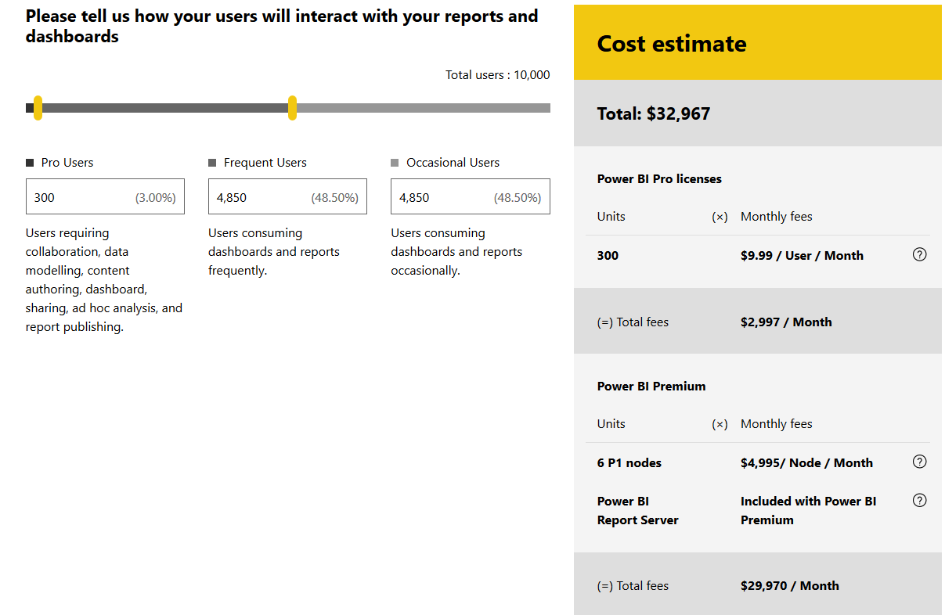](http://radacad.com/wp-content/uploads/2017/05/2017-05-15_06h29_13.png)

The costs is high of course, but if you compare it with purchasing 10K Power BI Pro plans ($100K) it is almost one third of that cost! As I mentioned before, you don’t need pay price of Pro for readers, so that makes your costs lower.  
Also you will notice in the calculator that this costing is including Power BI Report Server. so with this cost you are also able to host reports on-premises.

### But Would This Premium Cost Be Always Better?

No! Like many other things, it depends. If you are working for a large enterprise with thousands of users, and most of users are consumers, then as you saw in the example above it would be much more cost effective to purchase Power BI Premium licensing.

However, if you are medium size or small business with few hundreds of users or even less, then maybe Power BI Pro is better option for you. Here is an example;

If you have 50 users for Power BI, even if you purchase Pro account for them all, you have to pay $500 per months. However for premium you would need to pay at least $5K which is ten times more expensive. So with the current entry point of nodes (which is $5K), it is not cost effective to pay for Premium if you have such a small user base. simply continue using Power BI Pro.

If you need to host Power BI on-prem, you might still need to consider Premium even with small user base, because Power BI Report Server is available within Premium, or with SQL Server licensing (more details to come in the future).

## What is Break-Even Point?

One of the most common questions in this area is that when I need to use Premium, and when pro? what is the break-even point?

[](http://radacad.com/wp-content/uploads/2017/05/raquel-martinez-96648.jpg)

The answer to this question can be calculated easily. I cannot give you a precise number, because there are many different situations to consider details: Example: Two companies that have 5K users, and one of them might have 2K developers, the other one 200 only. One of them might have all users as frequent users, the other one 80% occasional users. Depends on your requirements number of nodes for Power BI Premium is different. and number of nodes has a direct affect on the costs.

I advise you to use the calculator and enter your total number of users, frequent users, and occasional users, then check if the total price with that requirement is lower than purchasing Pro account for all users, then you’re break-even point is passed. If not, then you can simply use Power BI Pro.

I’ve had two examples in my post already. here are summary of those again;

* A large enterprise with 10K users, which only 300 of these users are developers, and the rest are half frequent, and half occasional users. 6 p1 nodes of Power BI would cover this user base, and so the cost would be: 300\*$10 (per user Pro account) + 6\*$4,995 (per node Premium) = $32,967. This cost is far less than 10K\*$10 (per user Pro account) = $100,000. So this organization should use Premium obviously.
* A small/medium size business with 50 users, even if pay $10 for pro account for everyone, it is paying $500 per month. However, if this company purchases premium. The minimum entry point (At the time of writing this blog) is $4,995 which is ten times more expensive. So this company can simply continue using Power BI Pro.

# Summary

In Summary Power BI Premium is a great offering. It comes with lower pricing for enterprise scale customers, and with many features such as dedicated server, higher data set size, higher frequency of data refresh, Power BI on-premises and many other options. However, not all companies need these features, neither they have large user base. they can simply use Power BI Pro license as they are using already and enjoy the current offering. If you like to read more about details of Power BI Premium, I recommend reading [Power BI Premium Whitepaper](https://aka.ms/pbipremiumwhitepaper" \t "_blank) written by Amir Netz.

# Your Thoughts?

[](http://radacad.com/wp-content/uploads/2017/05/claus-grunstaudl-147900.jpg)

With Power BI Premium offering there were a lot of noises, questions, rumors, and comments about the offering. Some people said it is perfect, some said this is too expensive (the entry pricing), some said some of features should be available for Pro, and many other suggestions. Please note that this licensing plan is available to help in areas that other two plans couldn’t (you already know it if you read my post fully). However, I would like to use this post as a message to Microsoft and let then know about what do YOU THINK about this change? What is good or bad about it? Do you have any suggestions that can make this offering better? Please let us know in comments area, I’m sure Microsoft Power BI team will consider every comments here (I’ll pass these to them). Thanks in advance for your collaboration.

**Save**

**Save**

**Save**

**Save**

**Save**