Created in the cloud with Aspose.Words for Cloud. http://www.aspose.com/products/words/cloud

# Interactive Charts using R and Power BI: Create Custom Visual Part

Published Date : July 5, 2017

[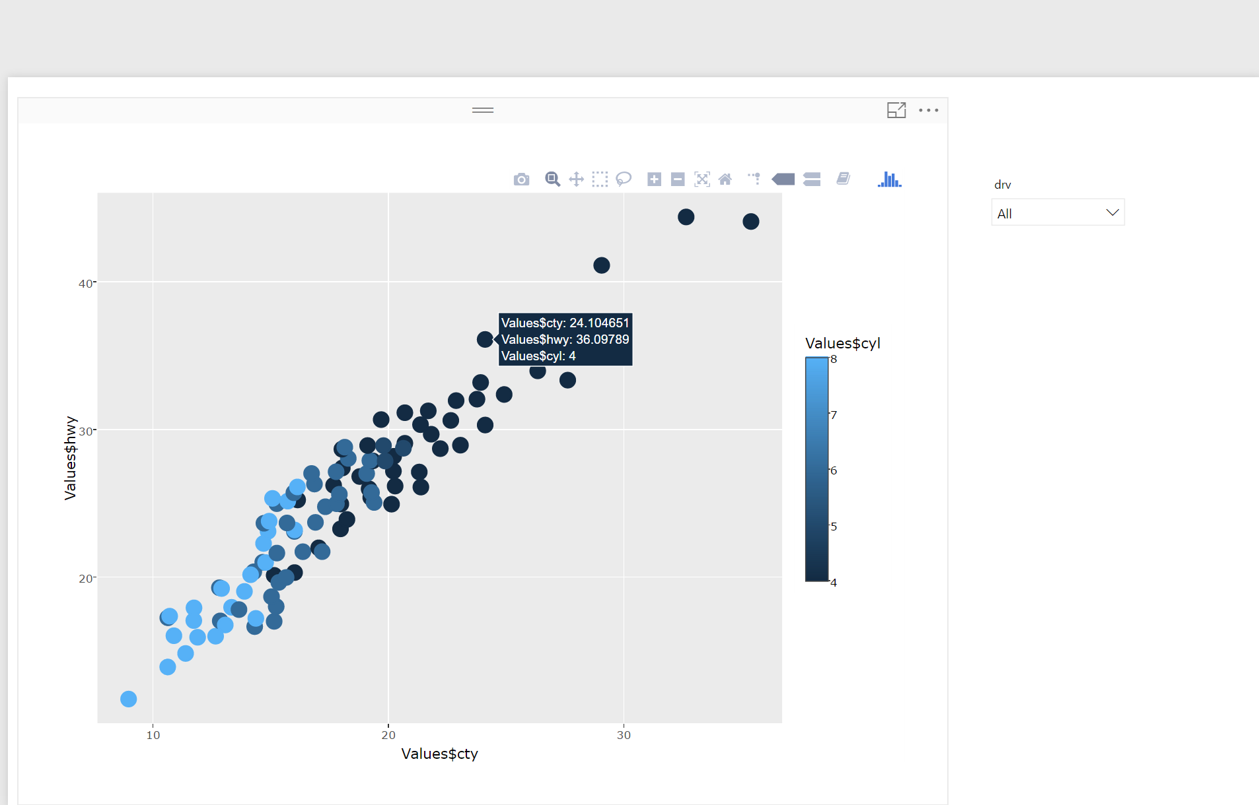](http://radacad.com/wp-content/uploads/2017/07/61.png)

In the last posts I have explained the main process of creating the R custom visuals.

In this post I am going to show how to:

1- Have more custom visuals

2- Different charts that we can have in Power BI

3- Explain some issues

## Have more custom visuals

to have more R visuals , it is now possible to use Plotly Packages by follow the Custom Visual Process.

In the last [post](http://radacad.com/interactive-map-using-r-and-power-bi-create-custom-visual-part-1) I have not explained how to create a custom visual for R and Plotly and how to have it inside the power BI.

I decided to try all Plotly charts that I used before, and Also I try to make some of my previous R visual as Interactive and as a custom Visual so every one able to use

I am going to create a Jitter chart to show three variable in a chart. I have show the main R codes in my Post about having more charts in Power BI[using R graphs.](http://radacad.com/have-more-charts-by-writing-r-codes-inside-power-bi-part-2)

I am going to show How to create two different R custom Visual one for Facet chart and the other for normal Jitter Chart

## Jitter Chart

**What I done**: First I back to the main folder that we have from the sample Power BI package,

1- I copy the folder to create a new custom visual (as it was my first attempts I call it Test :D)

[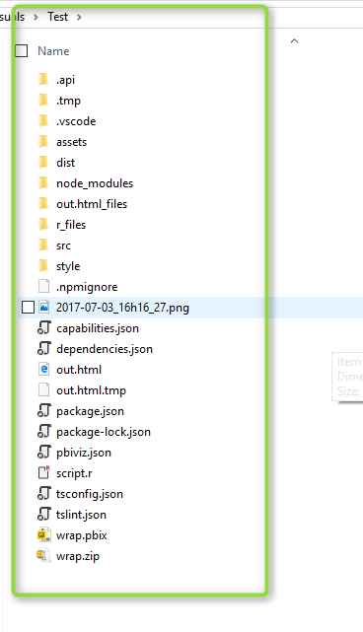](http://radacad.com/wp-content/uploads/2017/07/11.png)

2-I change the “pbiviz.json” files content: as below code.

{

"visual": {

**"name": "Test",**

**"displayName": " Test ",**

**"guid": "Testl216CAF192F6C439FAC22226710C3B3D4**",

"visualClassName": "Visual",

"version": "1.0.0",

"description": "",

"supportUrl": "",

"gitHubUrl": ""

},

"apiVersion": "1.7.0",

"author": {

"name": "",

"email": ""

},

"assets": {

"icon": "assets/icon.png"

},

"externalJS": [

"node_modules/powerbi-visuals-utils-dataviewutils/lib/index.js"

],

"style": "style/visual.less",

"capabilities": "capabilities.json",

"dependencies": "dependencies.json",

"stringResources": []

}

3-Then I have to put my R scripts inside the existing file name “scripts.r” . I have change the content as below to draw a simple jitter chart

as you can see the orange colour I made some changes

first: the main dataset will be stored inside the variable “Values” I put the value **Values$hwy** for the y axis and for x axis **Values$cty**. also I want to distinguish the number of cylinder of each car by different color  **colour = Values$cyl**.

libraryRequireInstall("ggplot2");

libraryRequireInstall("plotly")

library("plotly")

library("ggplot2")

library("htmlwidgets")

####################################################

**g=ggplot(Values, aes(x=c, y=Values$hwy,colour = Values$cyl)) + geom_jitter(size=4)**

################### Actual code ####################

####################################################

############# Create and save widget ###############

p = ggplotly(g);

internalSaveWidget(p, 'out.html');

4-Now I can run the package and add it to power BI (as I have described in last [post](http://radacad.com/interactive-map-using-r-and-power-bi-create-custom-visual-part-1)). See the blow picture. First, I have import the custom visual into power BI (number 1 and 2 in the below picture).

**to do** : I will show later how to change the icon of the custom visual.

next the custom visual just accepts the three main variable name as “cty, hwy, and cyl”. the variable should be name the same (number 3,4,5 and 6 in the below picture).

**To do** :in next chart I have replace them with (x,y,z,w,v) so it can be applied to all other charts and different datasets.

Finally in number 7. you see the charts.

[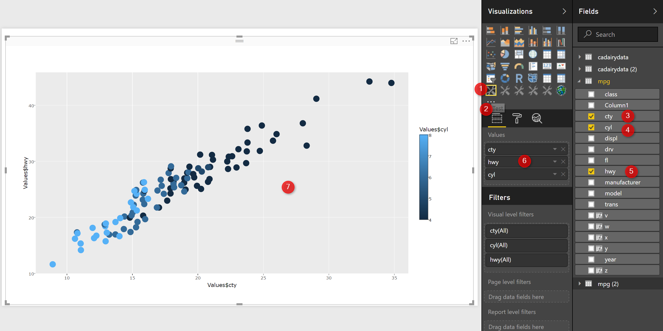](http://radacad.com/wp-content/uploads/2017/07/2.png)

Now, just by hovering your mouse on charts you able to see the tooltips for speed in city, high way and number of cylinder(number 1).

more over, there is a possibilities to zoom in and zoom out and also to select specific area of the charts.

[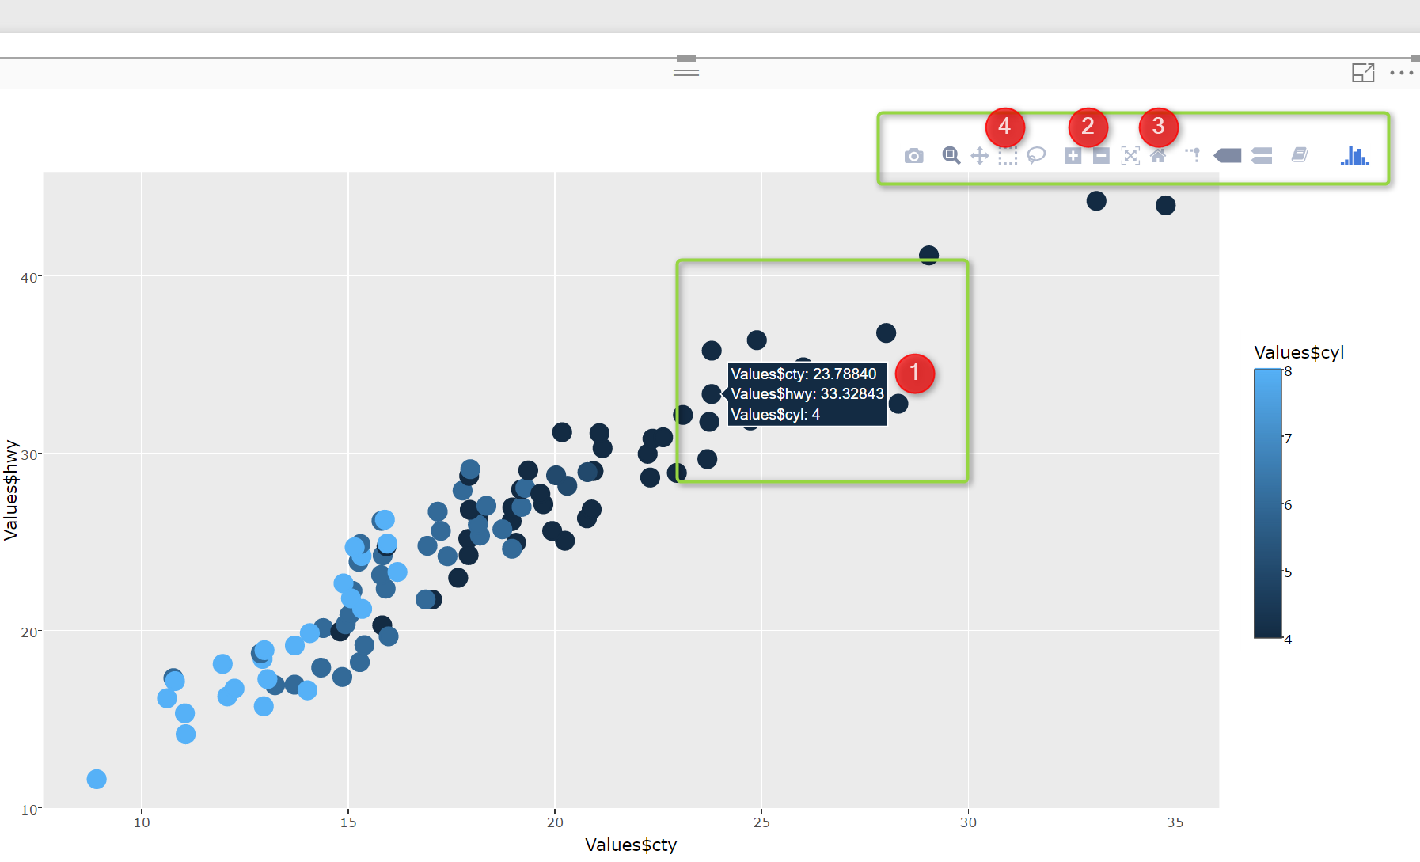](http://radacad.com/wp-content/uploads/2017/07/31.png)

I am able to select specific area of the chart and zoom in to see data,  also this picture able to be interact with Power BI slicer.

[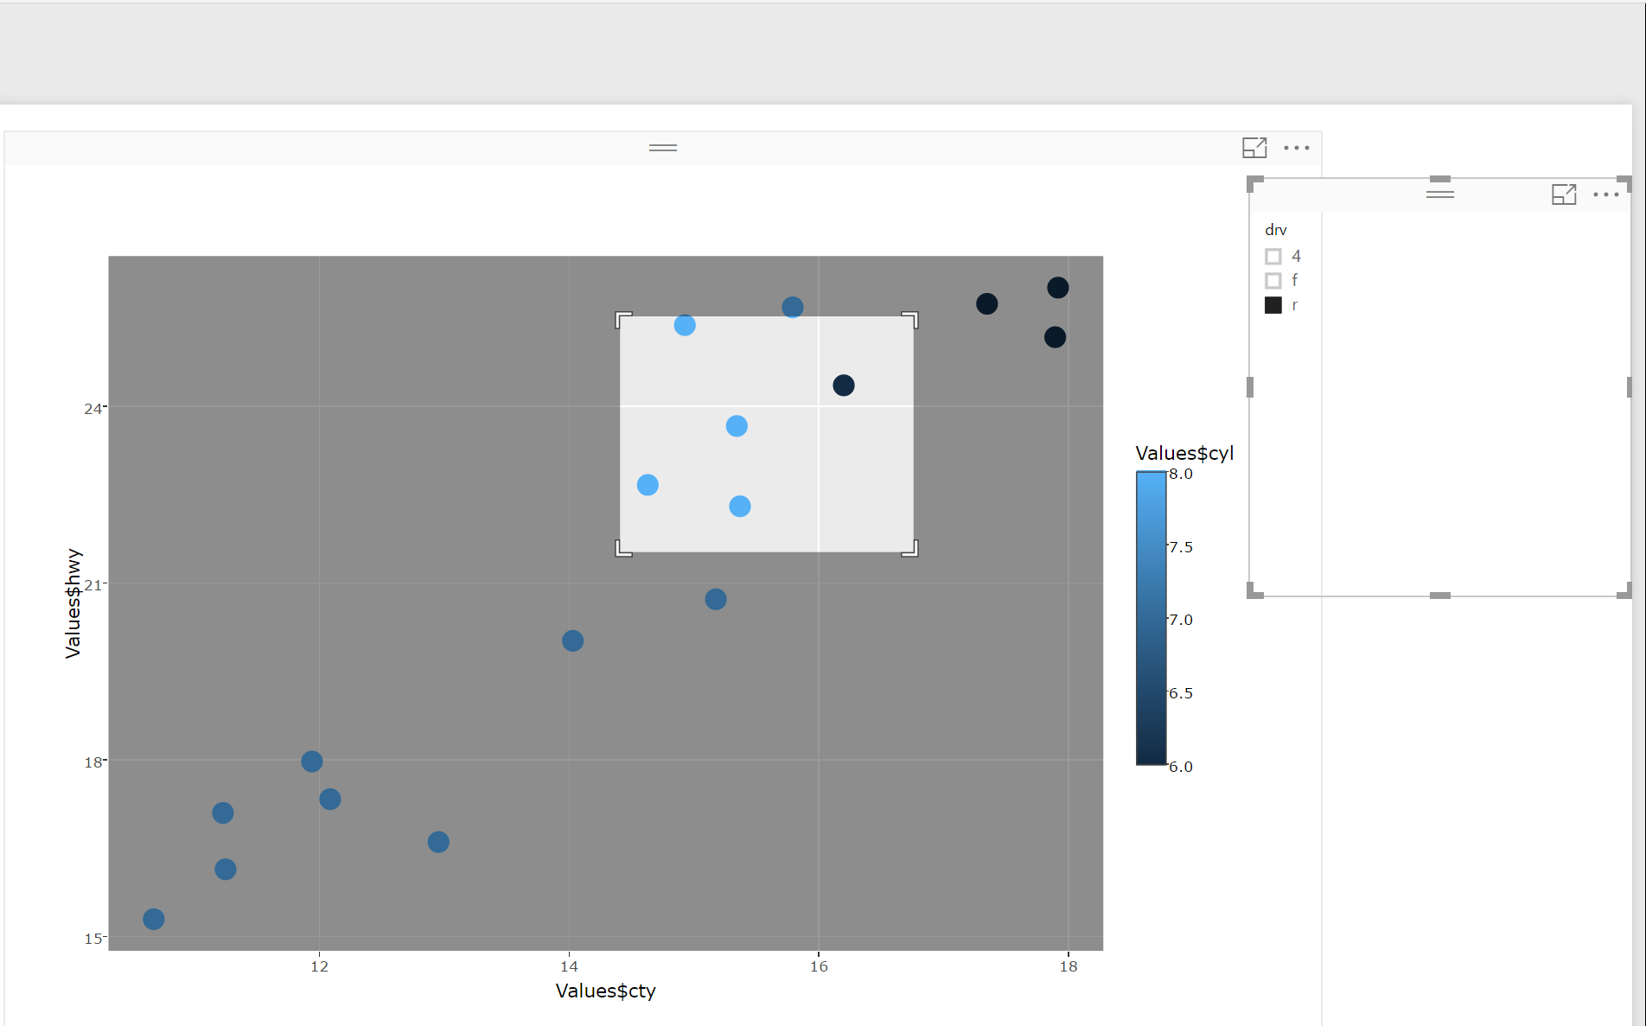](http://radacad.com/wp-content/uploads/2017/07/51.png)

In the next post I am going to show how to have more charts that we do not have normally in Power BI, make them as Custom Visual.

download the custom visual  from below

[Jitter chart (23 downloads)](http://radacad.com/download/5542/)