# Power BI Q&A; How to Ask Questions?

Published Date : March 11, 2016

[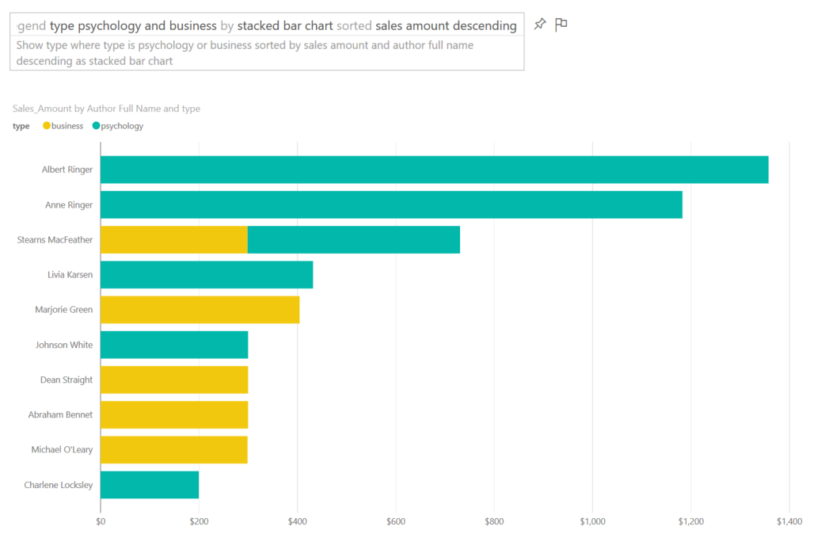](http://www.radacad.com/wp-content/uploads/2016/03/2016-03-11_12h41_50.png)

In previous chapters of [Power BI from Rookie to Rock Star](http://www.radacad.com/online-book-power-bi-from-rookie-to-rockstar) you’ve learned that Power BI reports and models can be published in Power BI website for sharing, scheduling and some other purposes. One of the features in Power BI website which is unique to Power BI and is not available in many BI tools in the market is Power Q&A engine. Power Q&A is a natural question and answering engine in Power BI. With Q&A you can ask your questions from the existing model with natural language and get response with visualization elements! In this post I’ll show you some of intelligence questions that you can ask from Q&A to get a very useful response.

# Prerequisite for Running Samples of this Post

If you want to run sample of this post and see how they works in action you need to create the Publication dashboard from the Power BI report built on top of Pubs database. In one of my earlier posts in the book I explained [how to create that report](http://www.radacad.com/power-bi-desktop-the-first-experience). You can also ask similar questions from any other model in your Power BI dashboard with just changing name of fields and values to whatever you have in your dataset.

# Explore the Data

When you published your Power BI file into the Power BI desktop, usually you create a dashboard for it. For Power Q&A to work (the version of Power Q&A at the time of writing this post) you should create a dashboard for your report. After creating the dashboard you will see the question bar of Q&A on the top of your dashboard.

[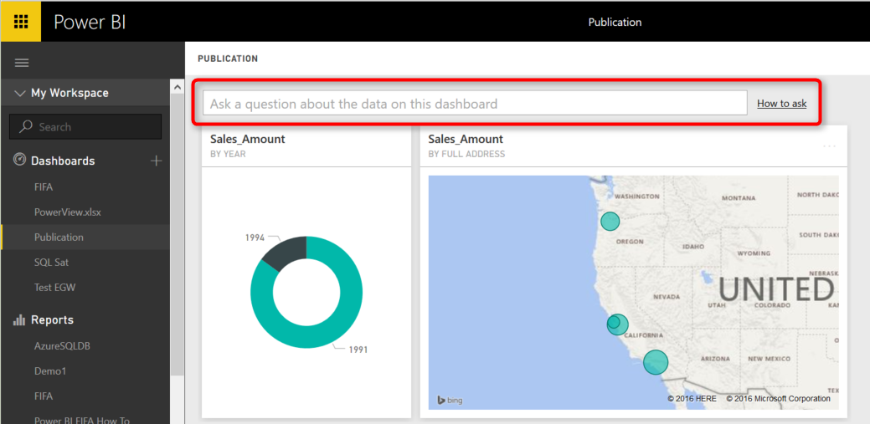](http://www.radacad.com/wp-content/uploads/2016/03/2016-03-11_11h52_31.png)

Let’s start by the most basic question:

# Explore a Dataset

by typing name of a dataset you can get it in a table view. You can either type in name of the table; such as “sales” or put a “show” keyword before it likc “show sales”

[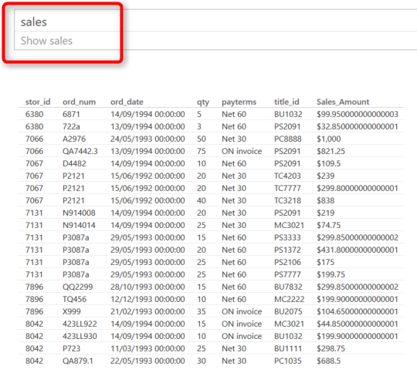](http://www.radacad.com/wp-content/uploads/2016/03/2016-03-11_11h59_16.png)

As you can see the Q&A is also smart enough to suggest you a sentense to ask the question.

# Filter Values

You can filter values with a WHERE keyword in your sentense. example below fetch all sales for the book titled “Is Anger Enemey?”

[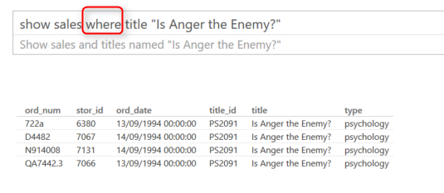](http://www.radacad.com/wp-content/uploads/2016/03/2016-03-11_12h02_15.png)

You can do date filters as well simply by mentioning the date. below sample shows sales for year 1994:

[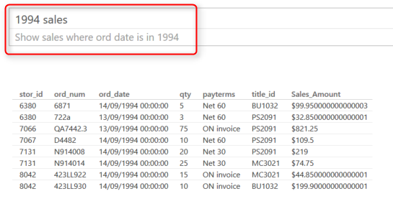](http://www.radacad.com/wp-content/uploads/2016/03/2016-03-11_12h04_23.png)

# Explore Related Datasets

You can explore data from related datasets. For example to get titles and authors (which are in two separate datasets) you can ask:

[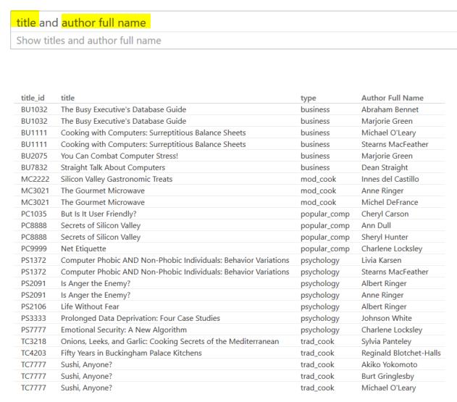](http://www.radacad.com/wp-content/uploads/2016/03/2016-03-11_12h07_12.png)

# Sorting Data

You can use Ascending or Descending commands in your question.

[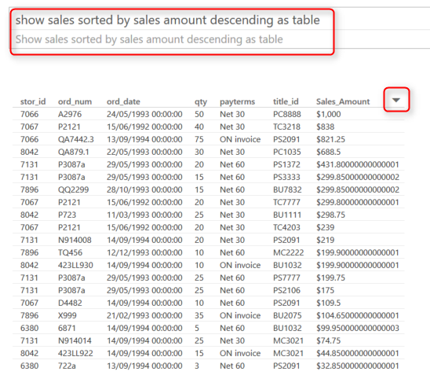](http://www.radacad.com/wp-content/uploads/2016/03/2016-03-11_12h11_25.png)

Also notice that you can change the order with simply hovering your mouse on each column and clicking on sort icon that appears there. I also have the “As Table” at the end of question above that force result set to be viewed as a table visualization.

# More Filters

## Equity Filter

You can filter on equity of values. such as sales on the payerms Net 60

[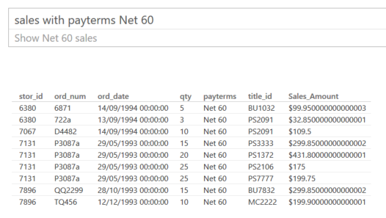](http://www.radacad.com/wp-content/uploads/2016/03/2016-03-11_12h15_07.png)

## Range Filter

Use “between” keyword to filter for a range

[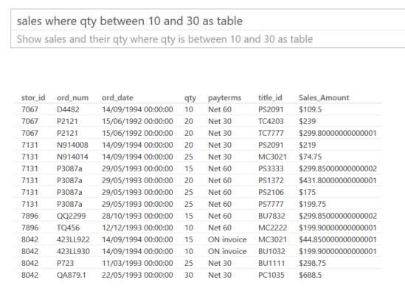](http://www.radacad.com/wp-content/uploads/2016/03/2016-03-11_12h16_48.png)

## Exact Date Filter

You can mention the exact date simply like sales October 28, 1993

[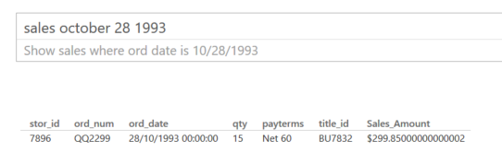](http://www.radacad.com/wp-content/uploads/2016/03/2016-03-11_12h19_02.png)

## Date Range Filter

You can filter dateset for dates before or after a date as below

[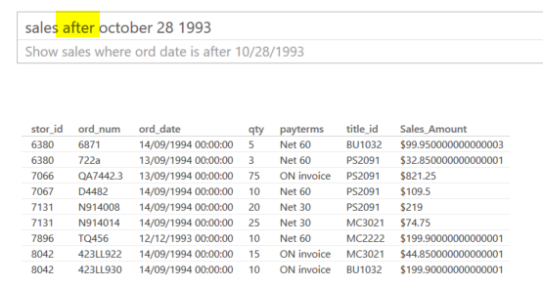](http://www.radacad.com/wp-content/uploads/2016/03/2016-03-11_12h23_46.png)

## Filter Relative to Today’s Date

Fetch data with filters such as past or next periods. for example fetch dataset information for past 10 years or so.

[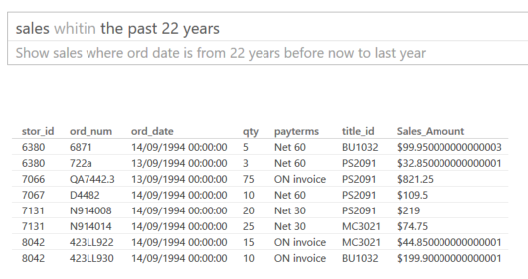](http://www.radacad.com/wp-content/uploads/2016/03/2016-03-11_12h26_33.png)

# Aggregation

You can even do calulations in your question, how impresive is that. For example ask Total Sales amount or Average Sales Amount

[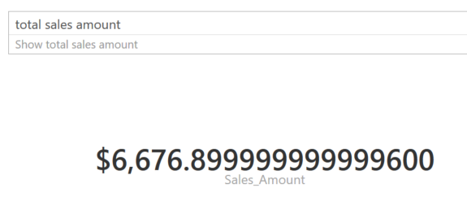](http://www.radacad.com/wp-content/uploads/2016/03/2016-03-11_12h28_34.png)

You can then aggregate across attribute values. such as; average sales amount per author

[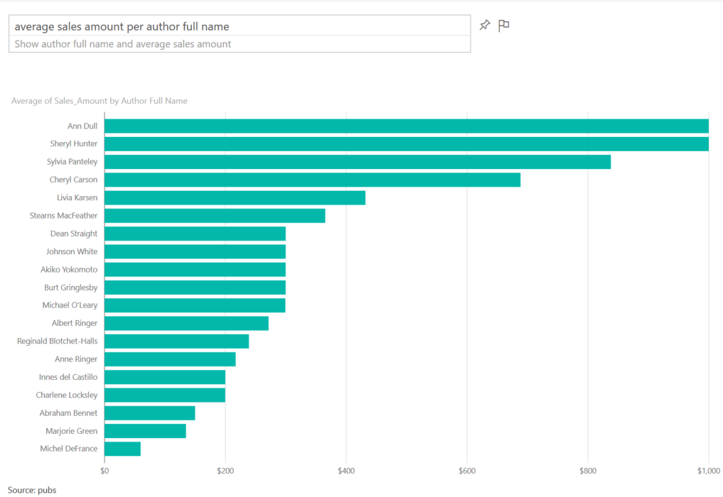](http://www.radacad.com/wp-content/uploads/2016/03/2016-03-11_12h30_24.png)

# Visualization Customization

You can ask what type of visual you want to see the result set to be shown.

[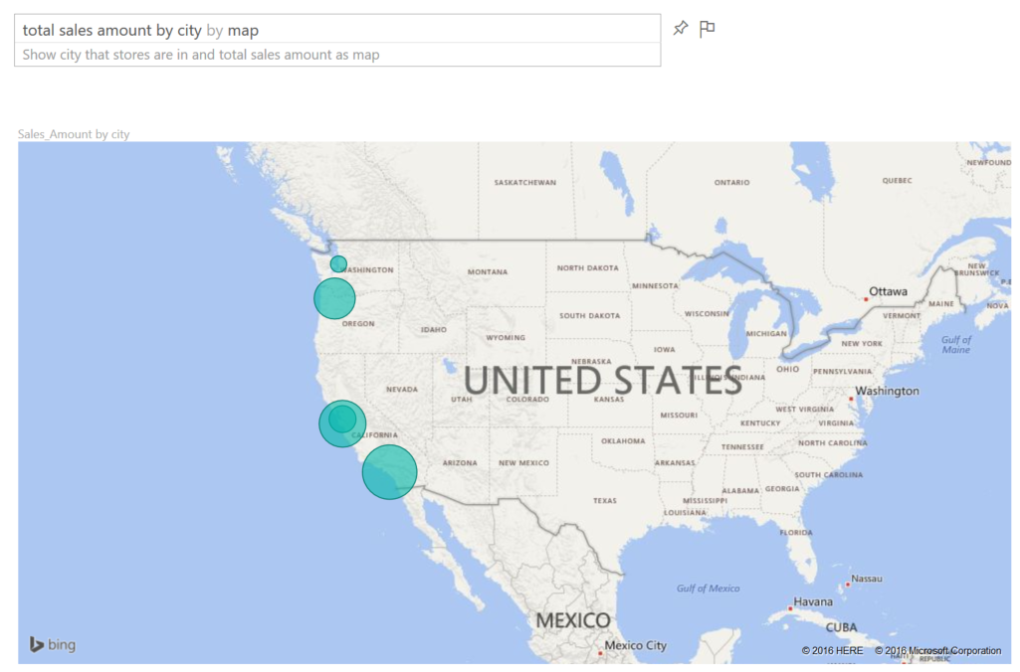](http://www.radacad.com/wp-content/uploads/2016/03/2016-03-11_12h32_57.png)

# Combination of some above

Now that you know some keywords to put in your question, you can ask questions that have combined items to create more useful reports such as:

[](http://www.radacad.com/wp-content/uploads/2016/03/2016-03-11_12h41_50.png)

You can pin every answer you want to your dashboard to save it for later.

There are some other keywords that helps you to ask better questions and get better answers from Power BI, but let’s keep this post simple for now. In future posts I’ll explain how to build you Power BI model in a way that responds best to question from Q&A. tips in creating relationship, naming columns, data types and etc.

# Your Turn

Now go to your Power BI dashboard and have fun with Q&A and bring some of examples you’ve done. I’d love to see what you will find 🙂