# Report Page Tooltip - Revolution in Visualization of Power BI

Published Date : March 8, 2018

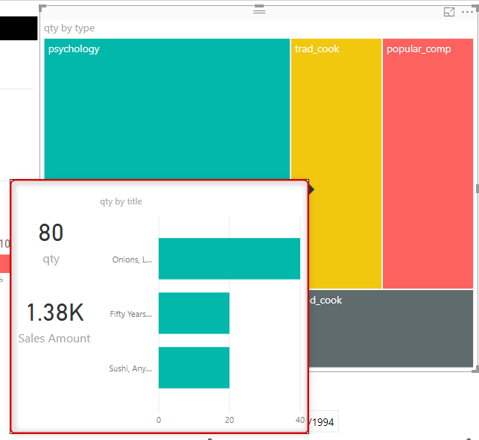

Very exciting feature that is added in the most recent version of Power BI Desktop March 2018 is Report Page Tooltips. This is a specific type of tooltip which can be a report itself. which this feature you can have your drill down report designed separately, and then with hovering on a chart, you can easily see the drill down as another report. This is a revolutionary feature added to Power BI Desktop, read rest of this post to learn how to use this stunning feature.

# Prerequisite

You need to download the Power BI Desktop release [March 2018](https://powerbi.microsoft.com/en-us/blog/power-bi-desktop-march-2018-feature-summary/). (Released few hours ago!).

You also need to enable the Report Page Tooltip feature (because it is still preview at the time of writing this blog post). You can enable it from Files, Options and Settings, Options

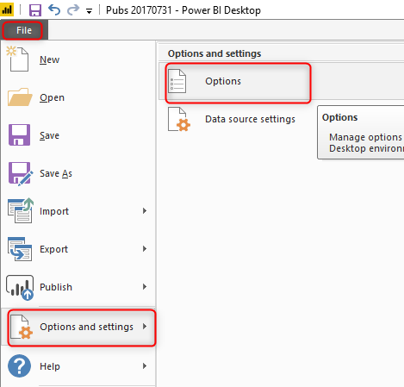

then you need to select Report Page tooltip option

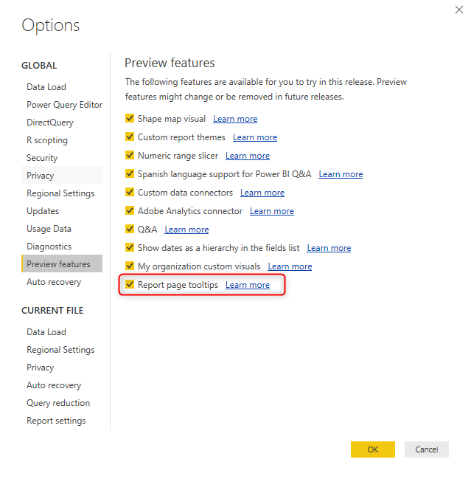

# Sample Report

Open a sample Power BI report. Here is my sample of Pubs data set;

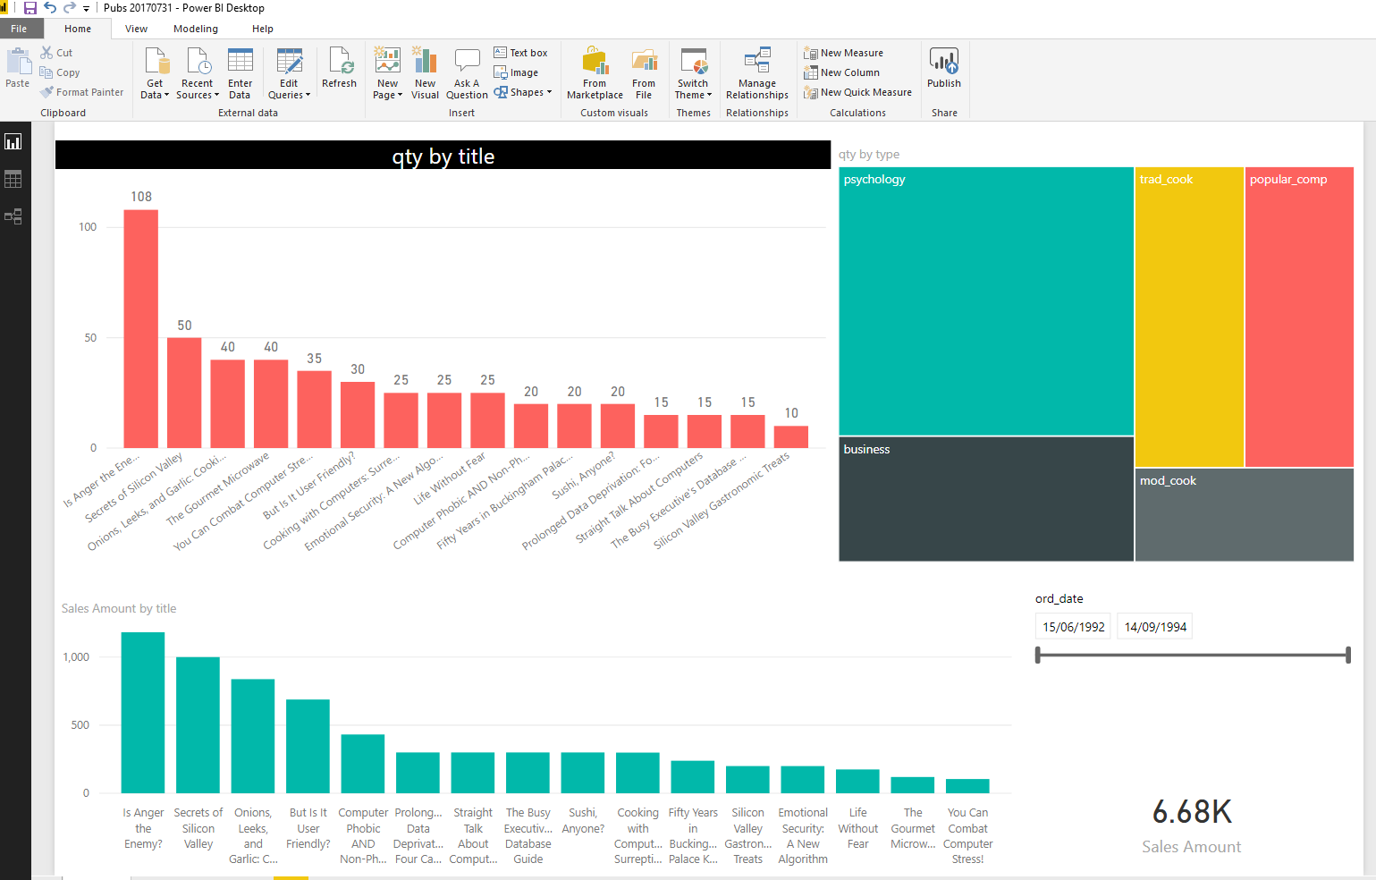

Let’s say we want to add a report page tooltip to the treemap visual. here are steps to do:

# Create a Report Page

First you need to create a new report page and assign it as a tooltip page. This is a normal report page with few specific features. Create the new page, and then in the page’s format settings, in the Page Information, set Tooltip to be ON

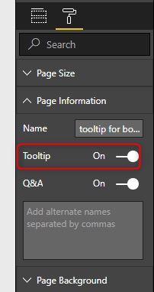

Then set the size of this page. You don’t want the big page to appear when you hover on a chart. you want a small screen. for example, I set these sizes:

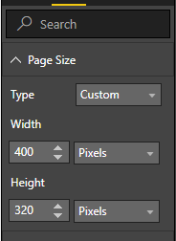

Now you can design your report page like any normal page. put charts and visuals on it.

You don’t need to put drill through filter on a tooltip report page

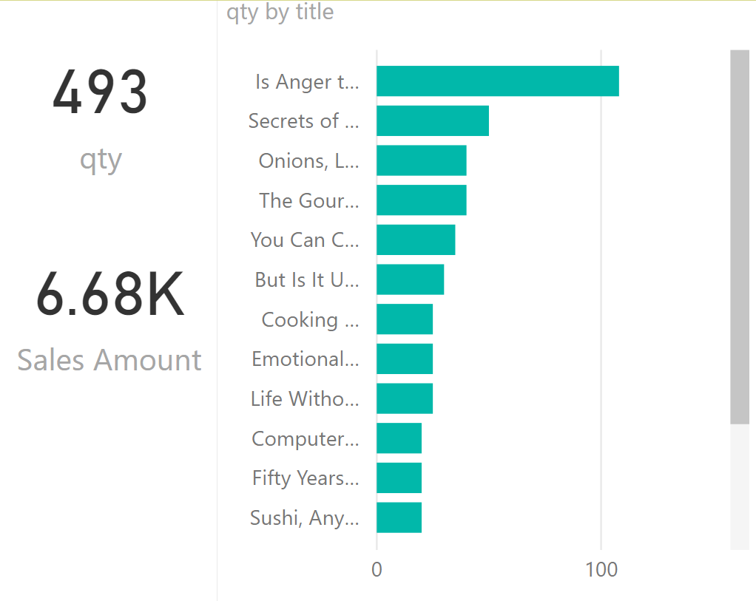

# Add the report as Tooltip

your report is now ready to be added as a tooltip to another visual. in the Format of that visual go under Tooltip and you would be able to select any report page that has the tooltip property of that ON.

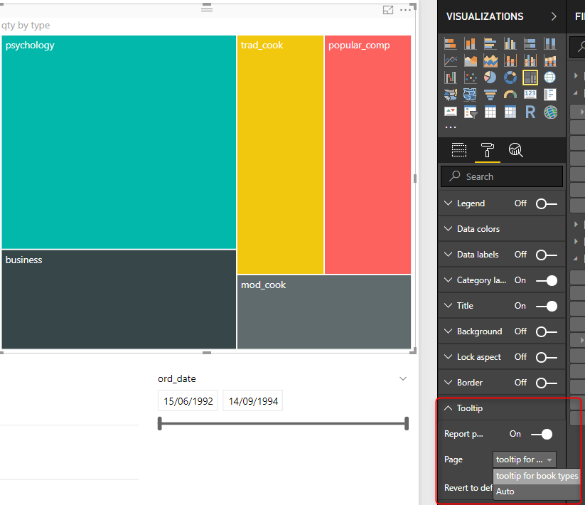

All done, let’s test it now

Test

When you hover with your mouse on the treemap, you can see the other report is now showed as a tooltip. Fantastic, isn’t it?

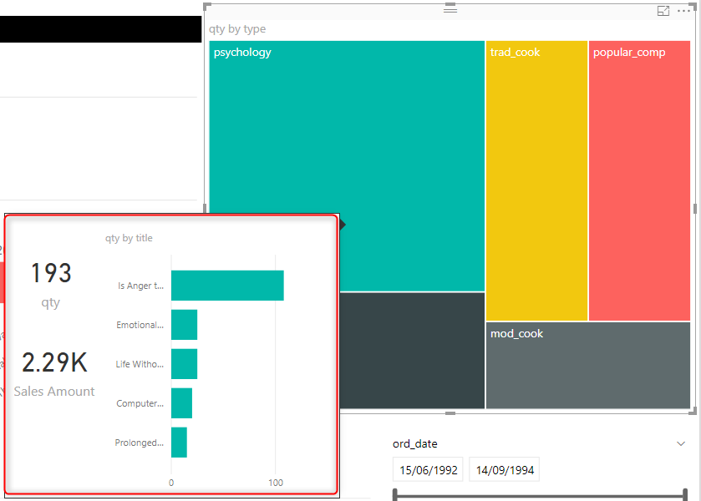

The great thing about this is that this automatically passes the selection, you can see the tooltip is only showing data of psychology now. if I hover on another types, then tooltip also changes. Very smart!



# Summary

This was a very quick post, but showed you a very fantastic feature added today in Power BI Desktop. from my point of view this is an awesome feature and probably reduce the amount of drill down and up in all reports. now you can drill down with different visual, you have the power of analysis with different visualizations in different levels. can’t wait to see more enhancement for this feature. Give it a try and let me know what scenarios you like to use this feature in it.