# Power BI Says Hi to 3D Maps

Published Date : November 25, 2015

[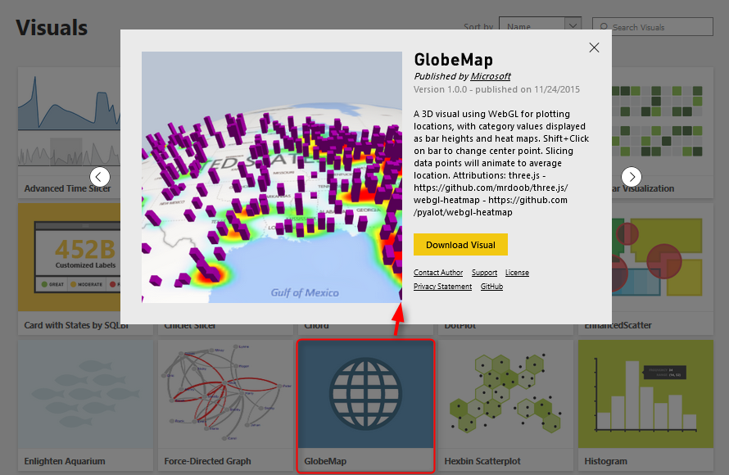](http://www.radacad.com/wp-content/uploads/2015/11/13.png)

If you’ve read my previous articles about Power BI, you know that Power BI has five main components: Power Query, Power Pivot, Power View, Power Q&A, and Power Map. So far all of these components were now supported in PowerBI.com website as part of your Power BI solution except Power Map! Power Map was the only component that you could use in Excel for Office 365 subscription, and it allowed you great 3D Geo-spatial visualization with ability to tell stories with videos based on animated tours. The great news today is that Power BI Desktop now supports 3D map visualization, but is that visualization same as what Power Map exactly does? Let’s find out.

# 3D Visualization in Power BI Desktop

I’ve heard of this features first in a session at PASS Summit 2015, and I was looking forward to see the feature be available to run some tests on it. My Particular interest was because I’ve done some interesting projects on Geo-spatial data visualization with Power Map for different clients, and I know what are their requirements in that area.

Fortunately today [Microsoft Power BI team announced](http://blogs.msdn.com/b/powerbi/archive/2015/11/24/visual-awesomeness-unlocked-the-globe-map.aspx) that 3D map feature added to Power BI through Custom Visuals. So let’s see how it looks like. For using this visual you have to download it first from Power BI Visuals Gallery:

<https://app.powerbi.com/visuals>

[](http://www.radacad.com/wp-content/uploads/2015/11/13.png)

After downloading this visual you can import it into Power BI desktop

[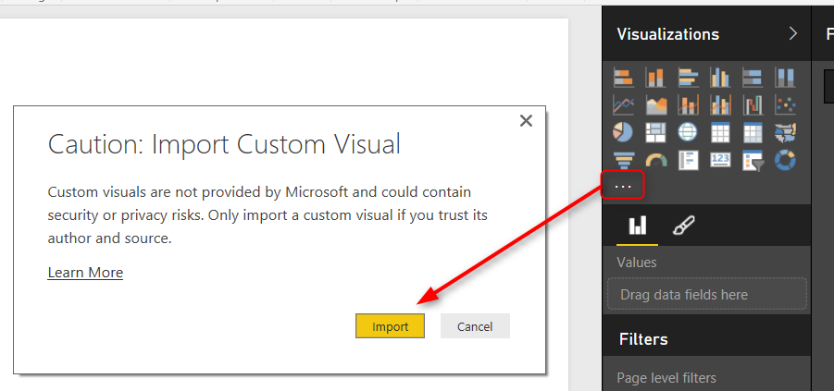](http://www.radacad.com/wp-content/uploads/2015/11/22.png)

Now you see Globe Map visual added to the visualization pane

[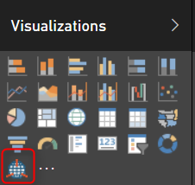](http://www.radacad.com/wp-content/uploads/2015/11/32.png)

I show my sample [Pubs map demo of Power BI](http://www.radacad.com/power-bi-desktop-the-first-experience) here with Globe and here it is;

[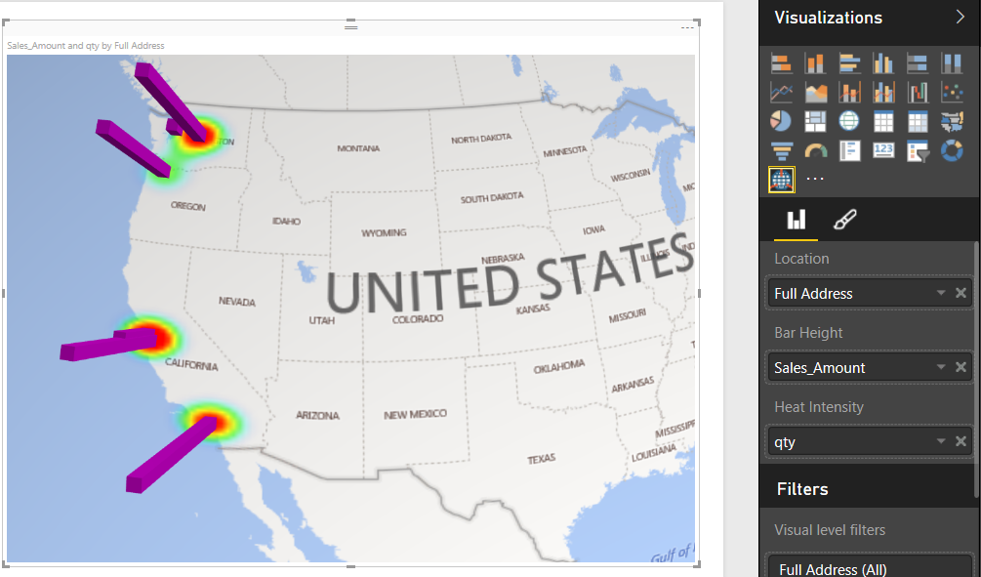](http://www.radacad.com/wp-content/uploads/2015/11/42.png)

As you see a nice 3D map showed here easily. However there is no particular options for it. it is just a 3D map! If I wanted to zoom into part of the map on a particular angle I cannot do that.

The map however is able to show two measures; one as the height of bar chart, and another one as heat map. you can see that above map shows sales amount as height, and quantity of sales as heat map.

You can not yet see Globe visual in PowerBI website, I reckon that would come very soon. but for now if you publish your report you will see this;

[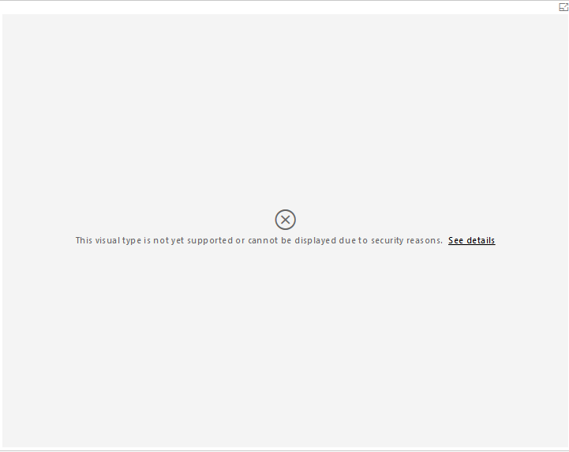](http://www.radacad.com/wp-content/uploads/2015/11/52.png)

One specific good feature of Power BI Globe visual is that it sync simply with other visualization items in the report (it is not isolated component as Power Map) , so if you click on column chart’s specific column you will see only related part of the data for that visualized in map.

[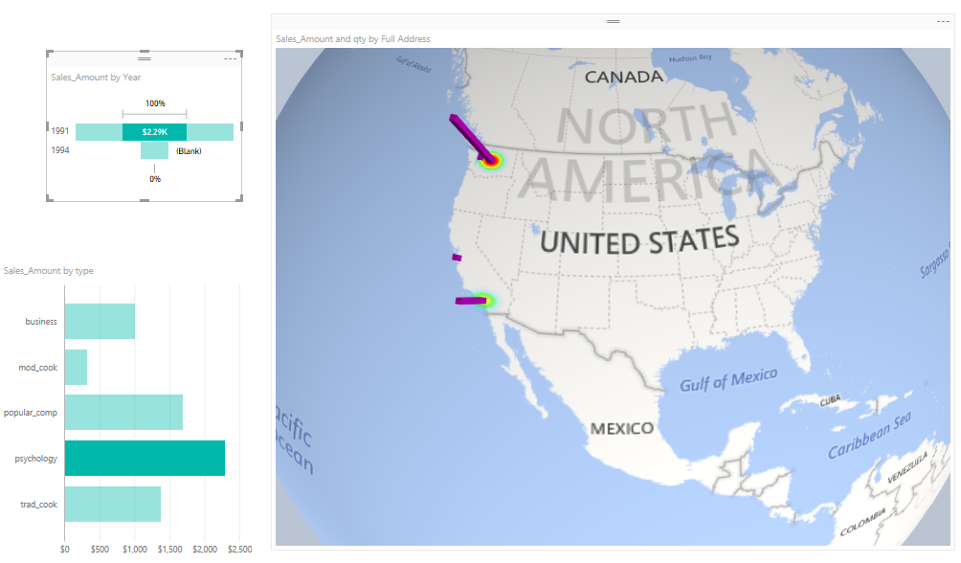](http://www.radacad.com/wp-content/uploads/2015/11/62.png)

# Power Map

Well Power Map is much more mature in 3D Geo-Spatial visualization, you can have different layers of visualization (such as column chart and heat map, and region visualization). You can zoom into map on particular angle if you want to. You can have a play axis which is very important for story telling.

[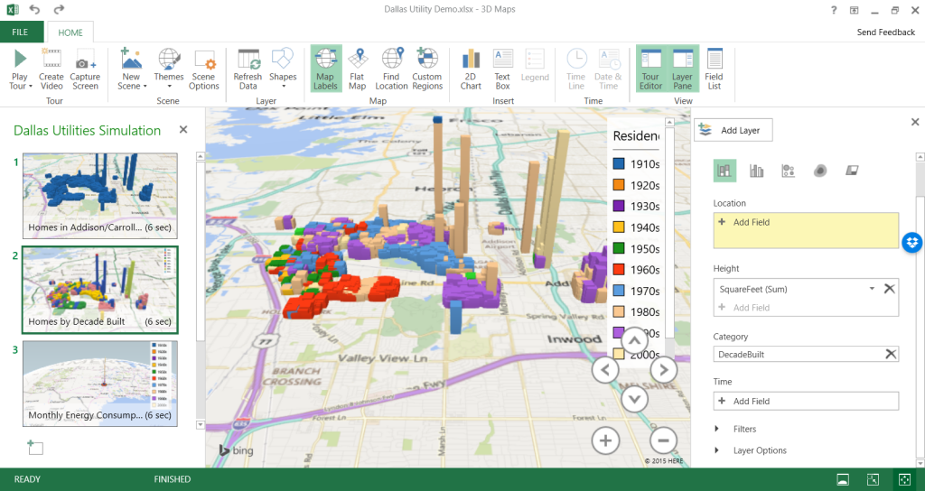](http://www.radacad.com/wp-content/uploads/2015/11/72.png)

Here are some features on Power Map, and the information about either they are or not yet supported in Power BI;

[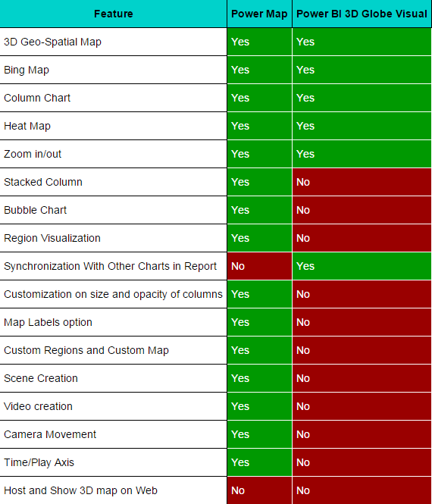](http://www.radacad.com/wp-content/uploads/2015/11/tbl.png)

# Conclusion

Power BI team did a great step forward with adding 3D map visual in Power BI Desktop. Thank you Microsoft Power BI team because of that! It is really useful for some scenarios that users need to see visualization on 3D map. However this feature is far behind Power Map features for story telling, creating tours, play axis, and many other features. I believe that soon many of these features will be added into Power BI. So I say Power BI said hi to 3D maps, but please be quick on that Microsoft team because Power Map raised expectations of our clients to a very high level! They will be looking for same features (at least) in Power BI desktop.

# A Question For You

Have you ever used Power Map or any other 3D Geo-Spatial data visualization tools? what are features of that (those) tools that you liked most? what are features that you didn’t used? What about Power Map? what are great features of this product from your (or your customers) point of view? and what needs to be added?

# ArcGIS Map in Power BI; Simple, But Insightful

Published Date : April 13, 2017

[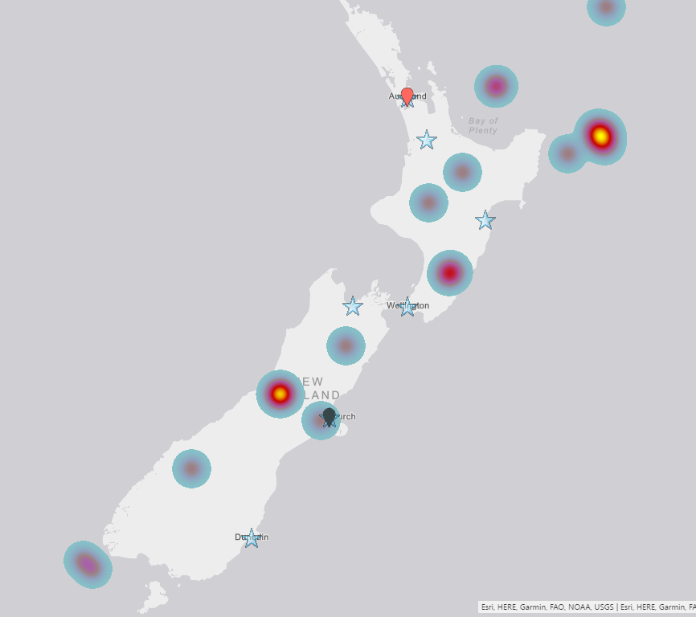](http://radacad.com/wp-content/uploads/2017/04/2017-04-13_11h21_18.png)

I have written about 4 other types of map visual with Power BI before. In this post I want to explain how ArcGIS visual work as a map visual. There are some specific features in this visual which is simple to use, but will give you a lot of insight. With this type of map visual, you can add multiple layers of data, and use even some of existing geo location information from ArcGIS map directory. Let’s go through an example and see what are features with this visual. To learn more about Power BI, read [Power BI book from Rookie to Rock Star](http://radacad.com/online-book-power-bi-from-rookie-to-rockstar).

# Maps in Power BI

There are many ways to visualize something on Map in Power BI, some of it are as below;

* [Map Visual](http://radacad.com/how-to-do-power-bi-mapping-with-latitude-and-longitude-only)
* [Filled Map Visual](http://radacad.com/power-bi-filled-map-the-good-the-bad-and-the-ugly)
* [Custom Visuals – Synoptic Panel by OKviz](http://radacad.com/custom-visuals-in-power-bi-build-whatever-you-want)
* [Custom Visuals – GlobeMap by Microsoft](http://radacad.com/power-bi-says-hi-to-3d-maps)
* [Shape Map Visual – Preview](http://radacad.com/shape-map-better-than-the-filled-map)
* ArcGIS Map Visual – Preview

I have written about them all expect last one. This post focus is on ArcGIS Map visual. Hopefully at the end I will write a post about comparison.

### Sample Data Set

For this example I will be using a sample data set which includes earthquakes in New Zealand in 2015! Not all of them, but part of earthquakes. Guess how many earthquakes listed in this file? 20,000! But don’t worry, it has listing of everything even earthquakes with magnitude of less than 1. To download the CSV data set file, use link below;

Enter Your Email to download the file (required)

# ArcGIS Map Visual

This visual is still preview at the time of writing this post, and for using it, you need to enable this preview feature. To enable it go through:

File Menu -> Options and Settings -> Options.

[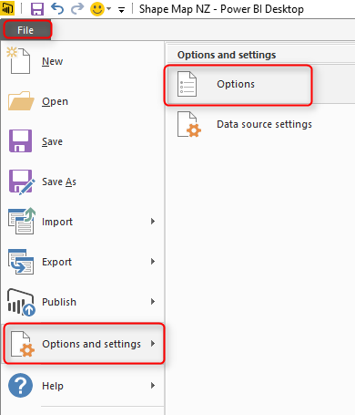](http://radacad.com/wp-content/uploads/2017/03/2017-03-07_10h30_42.png)

In preview features tab, select ArcGIS Maps for Power BI.

[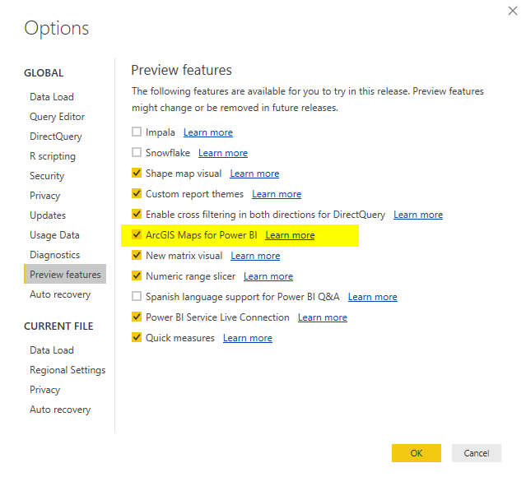](http://radacad.com/wp-content/uploads/2017/04/2017-04-13_10h23_42.png)

After clicking OK. you need to close your Power BI Desktop and re-open it again. You should be able to see ArcGIS Map visual in list of your visuals now.

[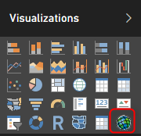](http://radacad.com/wp-content/uploads/2017/04/2017-04-13_10h24_59.png)

Get Data

To start with the sample data set, Get Data from Text/CSV, and select the quakes.csv file (link above in this post), Click on Edit in Navigator window, and you will see the whole data set. Only keep these columns and remove the rest: Longitude, Latitude, Magnitude, and Origintime. That means; just select these columns, an from right click menu click on Remove Other Columns.

[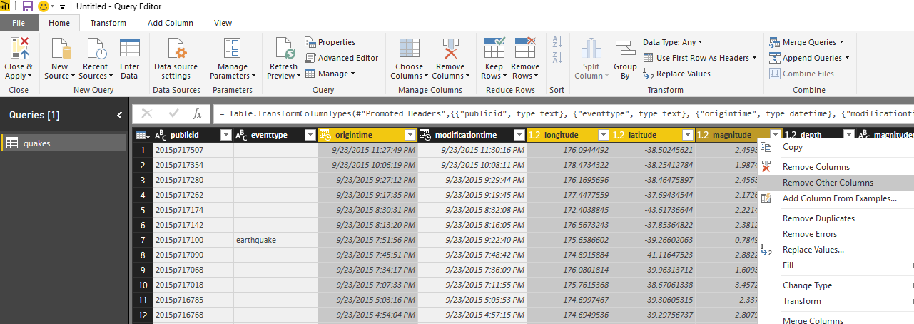](http://radacad.com/wp-content/uploads/2017/04/2017-04-13_10h28_51.png)

Close and Apply the Query Editor window. Drag and Drop a new ArcGIS map visual in the report, and assign values from latitude to latitude,  longitude to longitude, and magnitude from fields list to the Size section of the visual.

[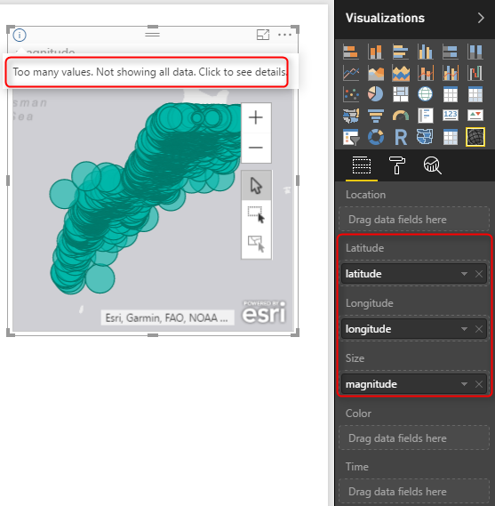](http://radacad.com/wp-content/uploads/2017/04/2017-04-13_10h31_38.png)

This visual, like the basic map visual in Power BI, has a limitation on the number of data points to show. because we have 20K data points it cannot visualize them all. Let’s filter the data set, and only focus on everything with magnitude greater or equal to 6. For doing this in visual level filter expand the Magnitude filter and apply filtering. Remember to click on Apply Filter, otherwise nothing happens.

[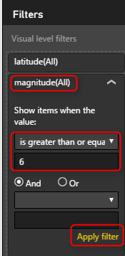](http://radacad.com/wp-content/uploads/2017/04/2017-04-13_10h33_53.png)

After applying filter, you would simply see only few numbers.

[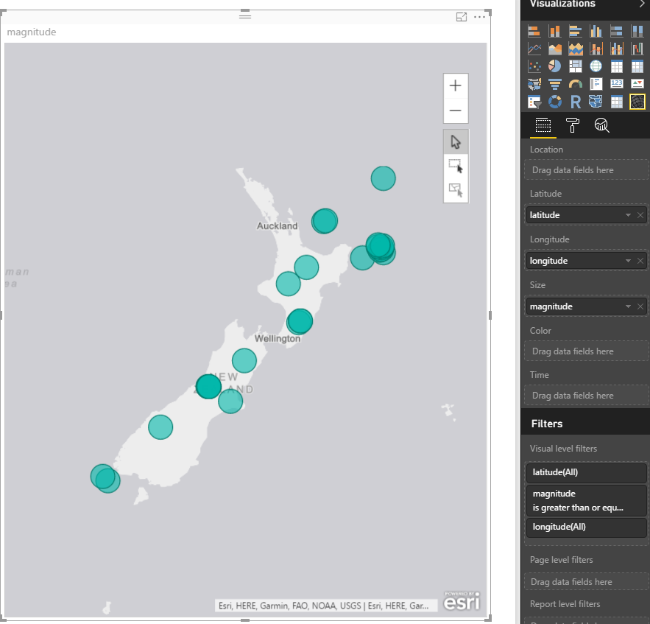](http://radacad.com/wp-content/uploads/2017/04/2017-04-13_10h39_39.png)

All of these earthquakes with magnitude more than 6 happened in 2015! can you imagine?!!!! anyway, let’s go back to ArcGIS map;

So far, the map is very similar to normal Power BI basic map visual with bubbles. Now let’s see what other options we have with ArcGIS visual;

# ArcGIS Features

To go through features of this visual, you need to click on three dots icon on the top right corner of visual and click on Edit.

[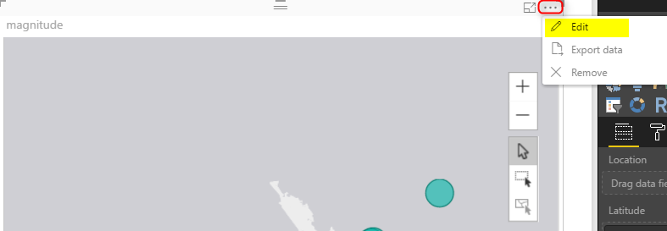](http://radacad.com/wp-content/uploads/2017/04/2017-04-13_10h42_11.png)

You will be redirected to an Edit mode, where you will see the map full screen, and number of menu options at the top;

[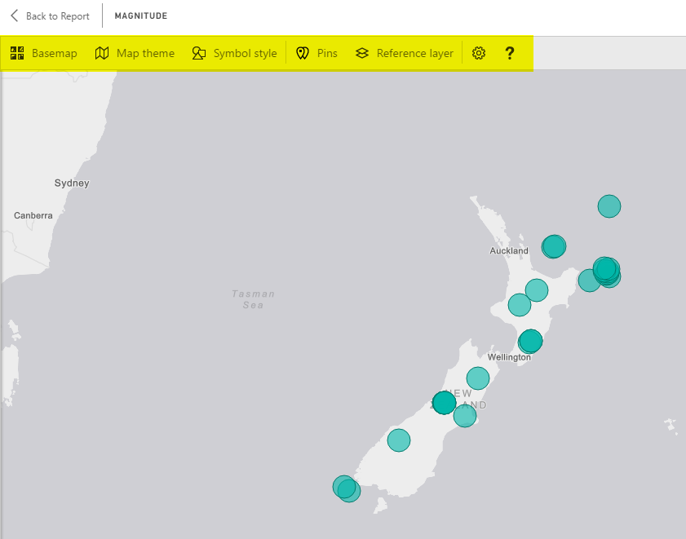](http://radacad.com/wp-content/uploads/2017/04/2017-04-13_10h43_21.png)

## Change Base Map

The first change you can make, it so change the base map, to be something different. You can choose from Dark Gray Canvas, Light Gray Canvas (Default), or Streets.

[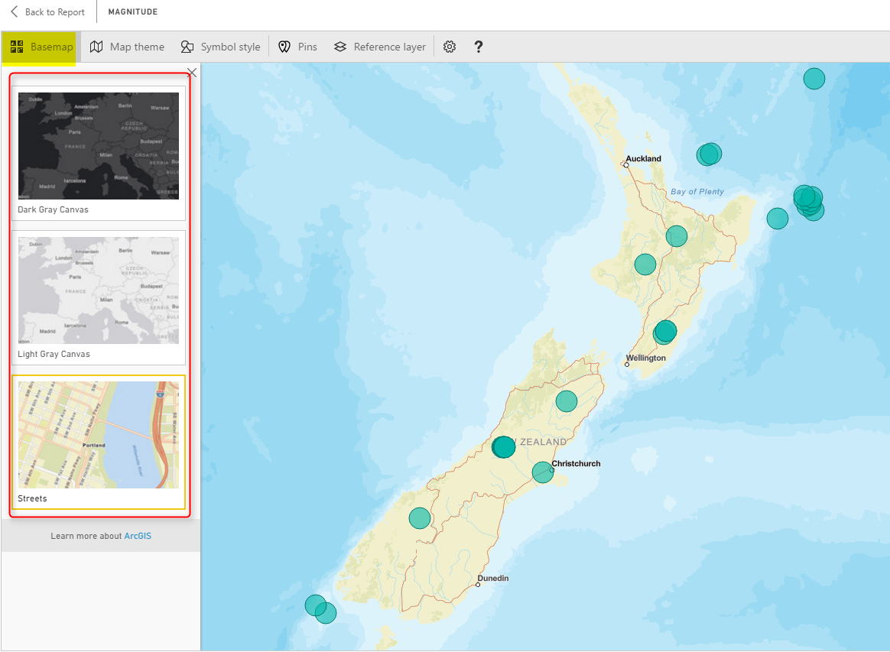](http://radacad.com/wp-content/uploads/2017/04/2017-04-13_10h45_16.png)

This feature is good to match the map with theme of your report, or even get some street information.

## Map Theme

One of the interesting features of this visual, is to change theme of Map. This type of map can give you four themes;

* Location Only – no size difference between bubbles
* Heat Map
* Size – bubbles with different sizes based on measure’s value
* Clustering – Good option for drill down

Clustering is good if you want to have high level view, and then ability to drill down into each region. Here is a view of clustering;

[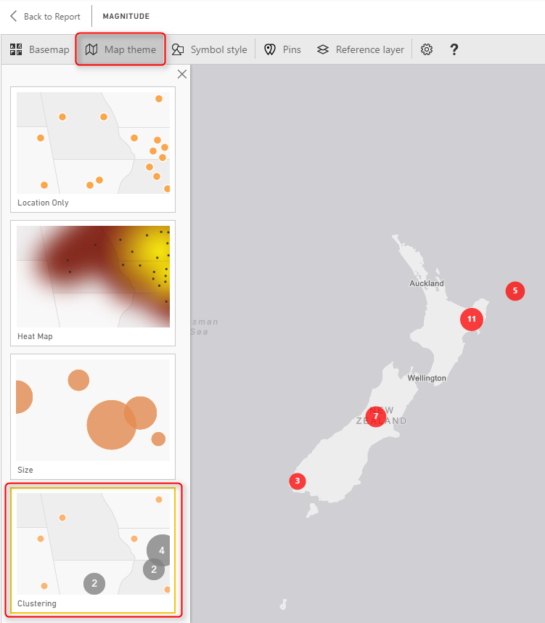](http://radacad.com/wp-content/uploads/2017/04/2017-04-13_10h52_43.png)

Each bubble shows you the total count of data point in that region (more you zoom out, bigger your region will be). and if you double click on a bubble you will drill down into that region;

[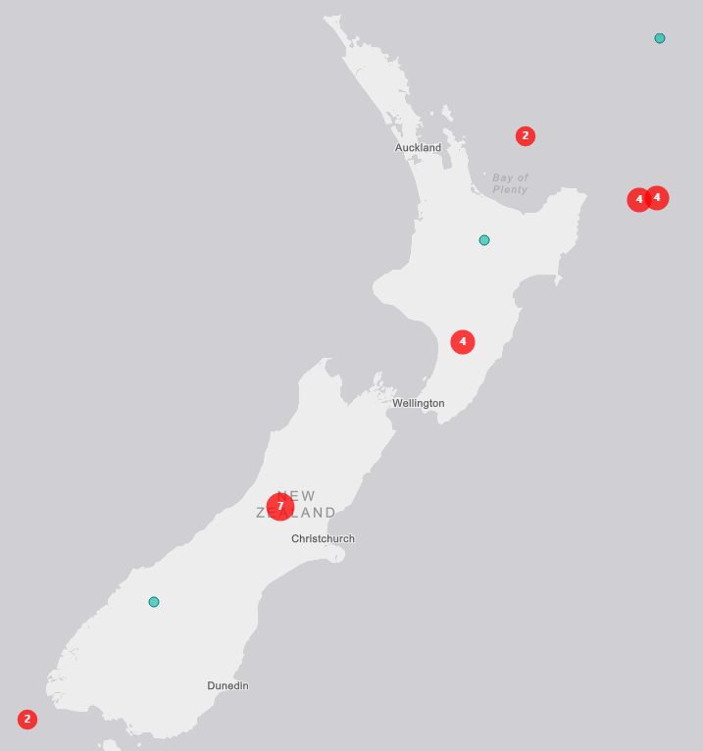](http://radacad.com/wp-content/uploads/2017/04/2017-04-13_10h55_58.png)

Heat map is a good visualization for showing the severity of earthquake in each area more graphically;

[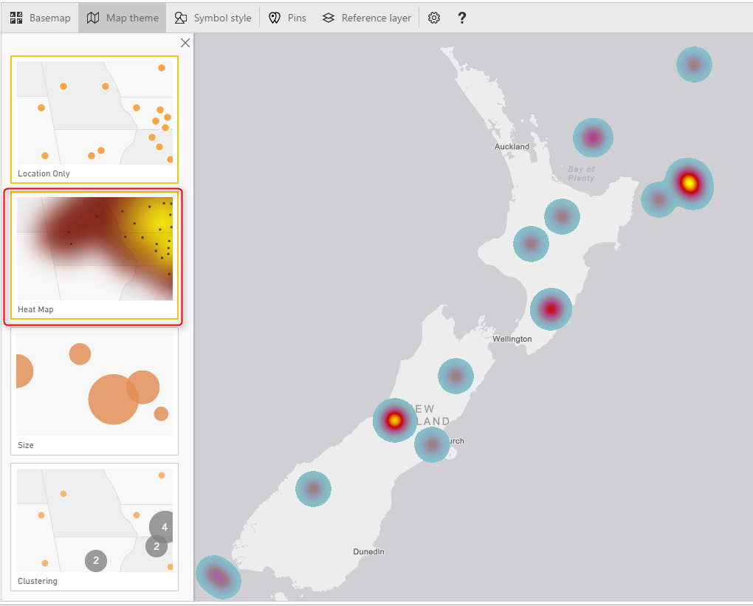](http://radacad.com/wp-content/uploads/2017/04/2017-04-13_10h57_03.png)

You can also use Location only or Size, which are simple to use.

## Symbol Style

Depends on what Map Theme, you’ve selected, you can do the details configuration of that in Symbol Style section. For example, if you have selected heat map, you can change the color. If you have selected size, you can change the bubble sizes and etc.

[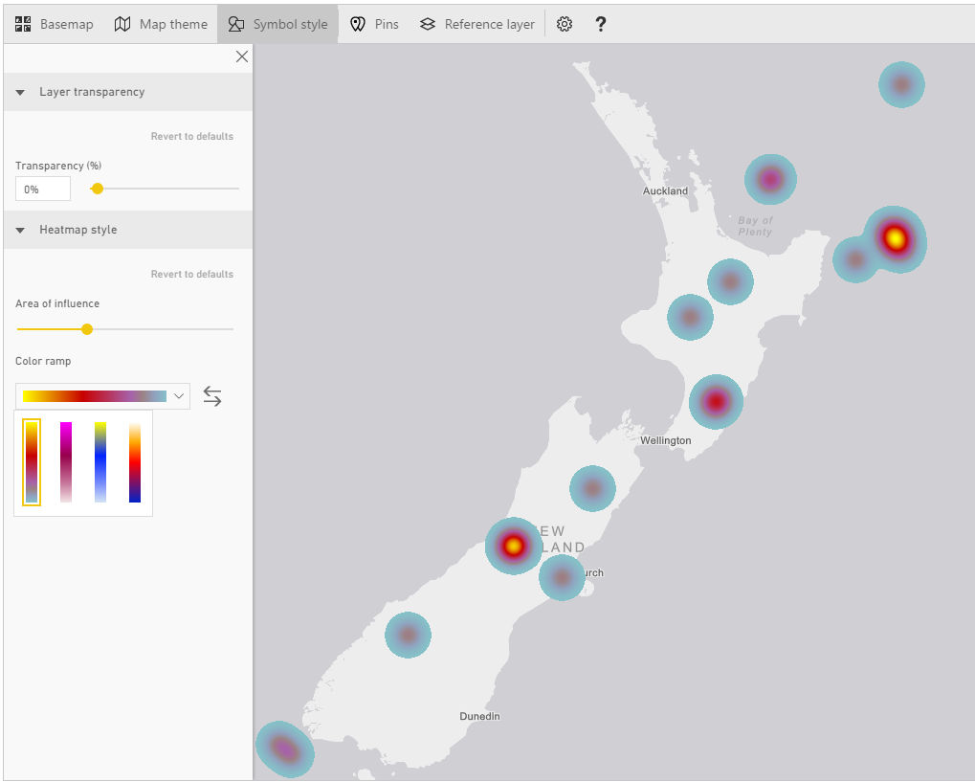](http://radacad.com/wp-content/uploads/2017/04/2017-04-13_11h06_04.png)

## Pins

You can add your own pins. These pins can be locations of branches, hospitals, schools, or whatever else you want to use as a pin on the map.

[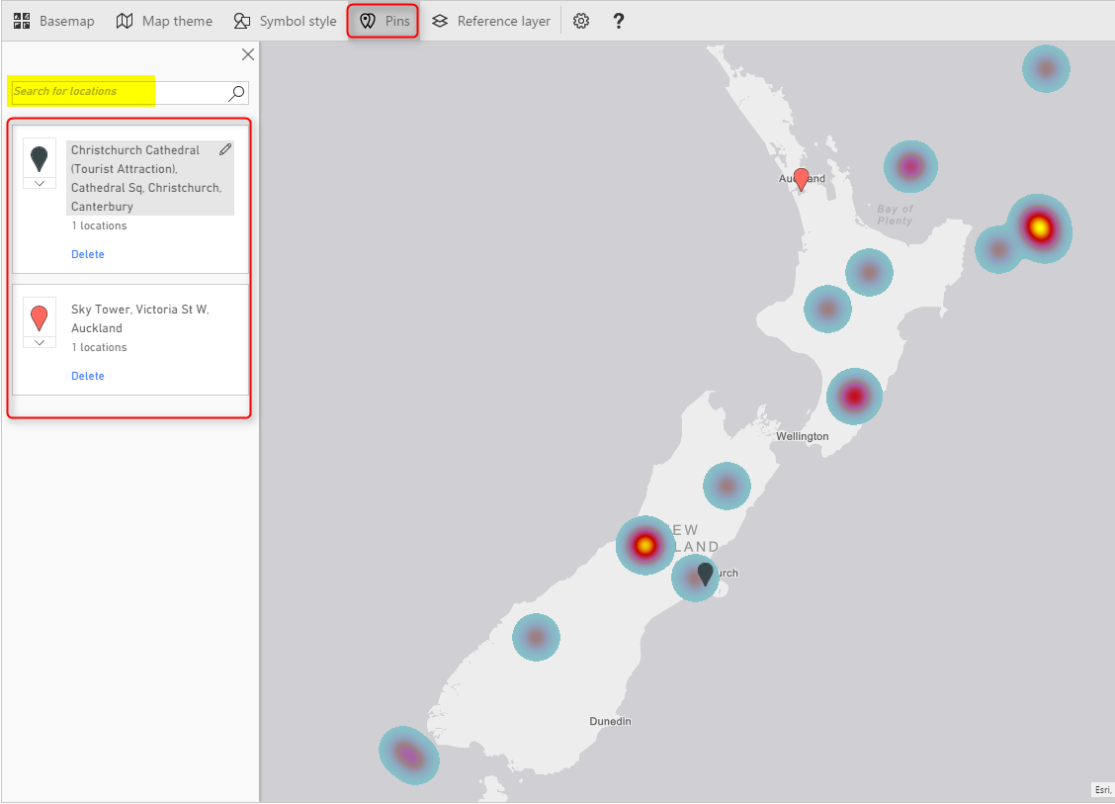](http://radacad.com/wp-content/uploads/2017/04/2017-04-13_11h08_20.png)

Reference Layer

The last feature, but not least is adding reference layer. In my opinion this is one of the best features of this visual. You can add another layer of visualization based on a map in directory of ArcGIS maps. [ArcGIS](http://www.arcgis.com/features/index.html) has many maps that you can use, almost map of everything! if you click on Reference Layer menu option, you can see some of existing maps for USA.

[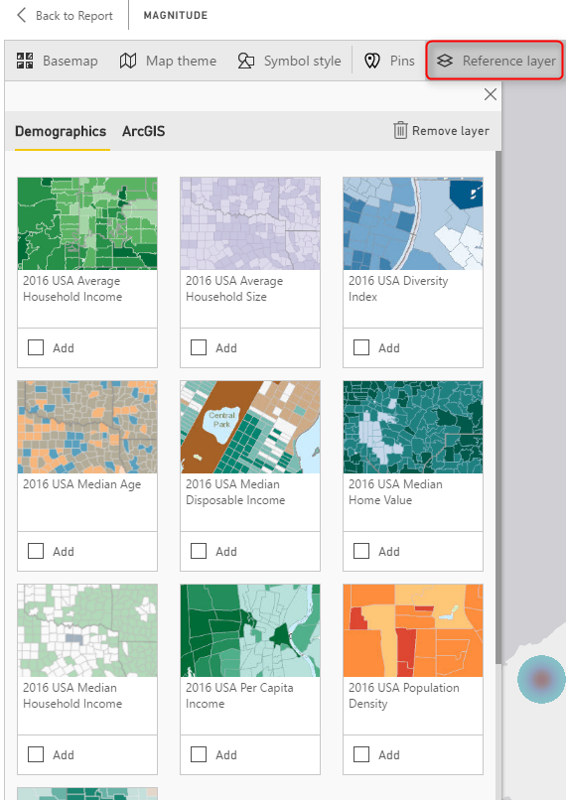](http://radacad.com/wp-content/uploads/2017/04/2017-04-13_11h13_21.png)

To access more maps, click on ArcGIS at the top, and there you can search for maps. For example below are some maps in New Zealand area;

[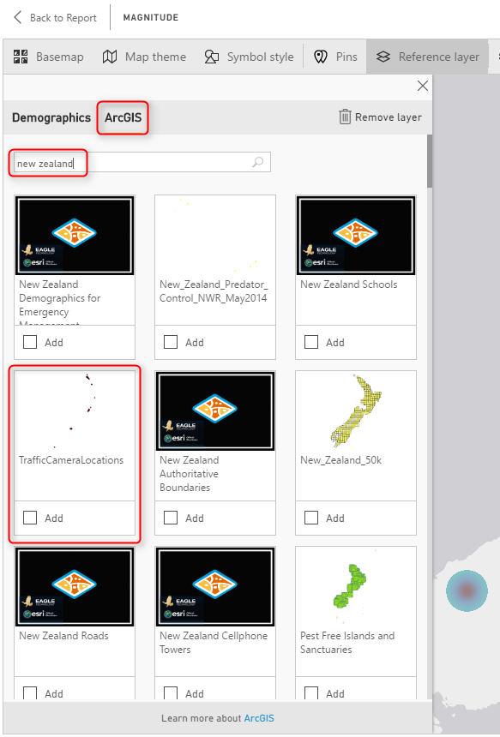](http://radacad.com/wp-content/uploads/2017/04/2017-04-13_11h14_41.png)

There are maps for schools, pipelines, gas stations, almost everything. Even there is a map for **Traffic Camera Locations**, Very useful map!

Because the current data set is for New Zealand 2015, and there was a cricket world cup in New Zealand and Australia at that time, so it might be good to bring a map of venues for that and realize are those cricket world cup venues close to the earthquake centers or not. Simply you can search for cricket world cup, and you will get the map very easily. Click on Add to add the layer to map;

[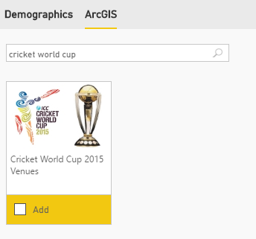](http://radacad.com/wp-content/uploads/2017/04/2017-04-13_11h18_06.png)

It will take few seconds for the layer to load, and now you will see locations with star mark on it. Wonderful, isn’t it?

[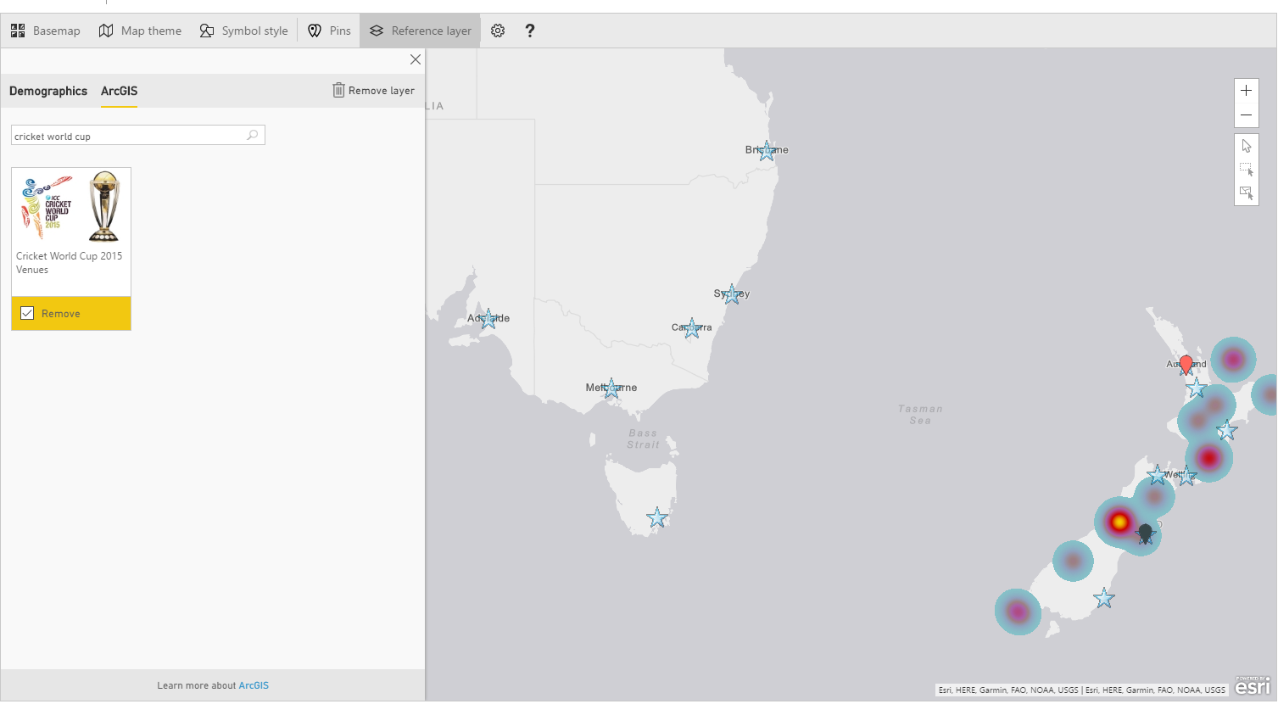](http://radacad.com/wp-content/uploads/2017/04/2017-04-13_11h19_55.png)

Now if you zoom in more to the New Zealand part of the map, you will see how close are venues. The venue in Christchurch was pretty close to one of earthquakes actually.

[](http://radacad.com/wp-content/uploads/2017/04/2017-04-13_11h21_18.png)

# Adding Time Dimension

All of above features can be much more insightful with adding a time dimension, and understanding how measure values (in our case earthquakes) happened through the time. If you bring Origintime to the Time section of this visual you will see a new time bar under the map, which you can select the time range for it, and click on play to see how earthquakes happened through the time. Similar to the [Play Axis feature in Scatter Chart](http://radacad.com/storytelling-with-power-bi-scatter-chart), Very insightful dimension to add.

[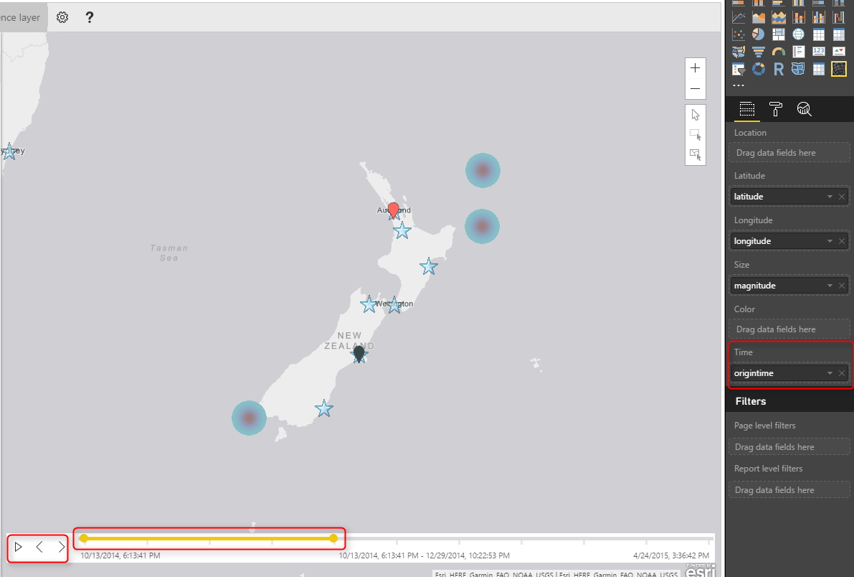](http://radacad.com/wp-content/uploads/2017/04/2017-04-13_11h27_50.png)

# Summary

I hope demos of this post has been motivate enough to show you the power of this visual. ArcGIS map visual is not like other map visuals, it is the best of all I would say. There are obviously pros and cons (which I will cover in another post later). However this visual gives you many things; using different themes, adding reference layers from ArcGIS map directory, and adding time dimension. These features are not easy features to use with other types of maps. There is just one part which is not 100% clear, and that is the licensing part of this visual. This visual at the moment is preview and free. However, I’m not sure how long it will be available for free. Because this visual is still in preview mode, expect to see some errors and bugs in it. sometimes you get an error. and you need to close Power BI Desktop and open it, which will be fixed I believe in the general availability version.

# Download Demo Files

Enter Your Email to download the file (required)

Save

Save

Save